

September 2026

P.O Box 99 Keilor 3036 www.keilorlife.com

Visit our Club Rooms Keilor Sports Club!

President  Joan Ellis  Mob: 0408 362 697  Jel48981@bigpond.net.au | Secretary  Glenys Adams -  Mob: 0414 757 632  admin@keilorlife.com | Web Master  Trevor Withers  t.withers47@bigpond.com  Carer  Judith Cave – Mob: 0408 301 057
Vice-President  Judith Cave  Mob:0408 301 057  info@keilorlife.com | Treasurer  Sue Lovell  Mob: 0402 056 070  Assistant Treasurer  Neil Webster  Neil13web@aol.com | Membership Secretary  Elizabeth Dowsett  Mob: 0481 008 462  Photographer  Dianne Robinson  Mob: 0438 242 512
AGM President’s Report 2026
KLAC has continued to prosper throughout 2025 /2026. Since moving back to the club rooms, 7TH July 2025, each week, we have welcomed new members, increasing our membership by 21%.
It is building with young people, 50 plus! for the longevity of our club, this is a must.
Thank you to Hayden Kelly, Sports Club President, and his team whose blood sweat and tears have given us an incredible space we call home. Our club rooms.
The extra floor space has allowed us to comfortably add three more activities, “Meditation in Motion”, “Yoga”,” Latin Line Dancing”. We offer our members twenty activities, both passive and active.
Thank you, our conveners, who are very inclusive, continue to make sure the activities are conducted in a fun, enjoyable safe way.
Thank you to our instructors, who give their all to keep us healthy and hungry to live a longer and healthy life. Jenny Kelly, Ellen Mairon, Lucy Lugowski, Di Lukey, Maria Ballesta, Yong Kuo.
I am so thankful for your commitment to our KLAC members and the community in general.
Thank you to Lee Falcke, (Sports Club) we would be lost without his support and patience.
Thank you to all our committee members,
Jenny Craig, Sue Lovell, Judith Cave, Neil Webster, Elizabeth Dowsett, Barbara Griggs, Norma Cocks, Dianne Robinson, Glenys Adams, Denise McGhie, Trevor Withers (Web Master), Georgina Hall (Purchasing Officer)
These kind people have given their time and skills unconditionally this past year as we have worked through some teething problem moving back into our club rooms.
Last and not least, our biggest supporters, KLAC members. The members who contribute to our monthly trading table and book club. The trading table proceeds give back to our club and the proceeds from the book club go to the Royal Children’s Hospital.
Fortunately, we have many members who put their hand up to assist where needed, thank you, your support in making KLAC an incredible Seniors Club, that I am so proud to be President of.
Thank you.
Joan
“In unity, we find not just strength but also joy in our journey.”

Club Supporters
We are ever grateful and acknowledge the ongoing support of:


Warwick Borello
Accountant Support



KLAC is blessed with new additions to our team of leaders allowing the team to introduce leading positions for our committee members. This makes it easier for our members to have a point of contact when addressing situations. I introduce you to the positions these committee members will lead on the committee.
President - Joan Ellis
Vice President - Georgina Hall
Secretary - Glenys Adams
Treasurer - Sue Lovell
Assistant Treasurers - Neil Webster, Gloria Kotula
Membership Secretary - Elizabeth Dowsett
Purchasing Officer - Georgina Hall
Convener Co Ordinator - Barbara Griggs
Trivia - Elizabeth Dowsett
Bingo / Raffles - Jenny Craig
Hospitality - Dianne Robinson
Theme Days - Elana McKinley, Norma Cocks
Please Note: ALL committee members are there to assist you.


NEXT BUS TRIP
Friday 23rd October 2026
Depart Keilor Hotel Car park 8.00am and travel to The Big Stupa in Bendigo.
It is the largest stupa in the western world. You will partake in a tour of the most sacred building in Buddhism. There will be free time to purchase morning tea (at own cost) and to wander through Peace Park.
Then onto The National Hotel, arriving 1.00 pm for lunch. We depart 2.30pm arriving home approximately 4.00 pm.
PLEASE NOTE: it is your responsibility to enter your name on the activity sheet in the club rooms. Please DO NOT ring the convener, Dianne. The trip will be capped at fifty members.Total package includes entry fee, tour, and lunch with a drink at The National Hotel. Cost per head $77.

Fun with the golf group
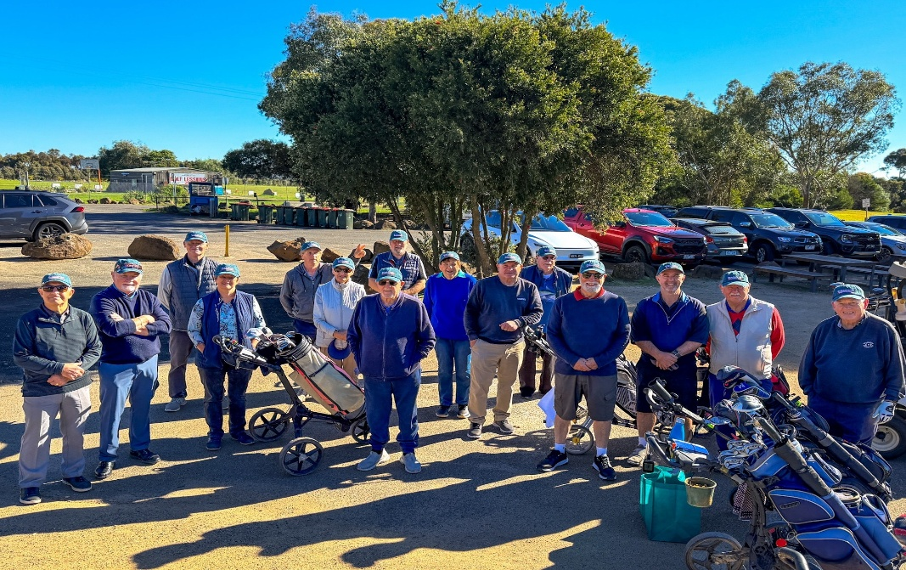
What an inspiring group! They are our fellow club members.
If anything makes us all proud, it is the guy in the middle front of the scene Ian Kelly. He is a KLAC Golden Member (over 90 years on this earth) Ian fronts up each week playing 9 holes (rarely takes more than 48 shots)
Ian (in his hay day) played cricket with Footscray, baseball with Sunshine and Umpired district cricket for many years. What an inspiration. We are not only inspired by you, Ian, we are very proud of you.
A big shout out to Bunnings Ballarat Road, Sunshine. They have supported our KLAC Golf group donating great caps for all. Thank you.
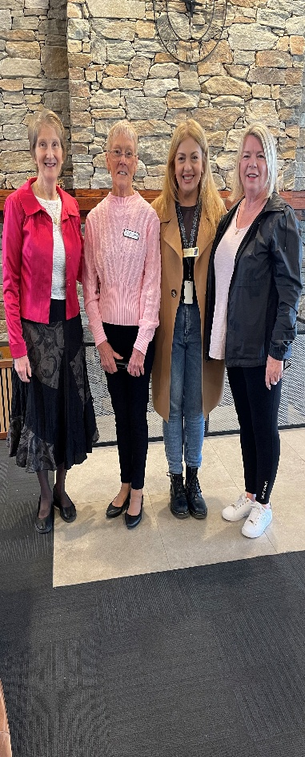
If you think your retirement could include a game of golf with a vibrant, inclusive group, contact
Mark Lipplegoes 0415 356 259

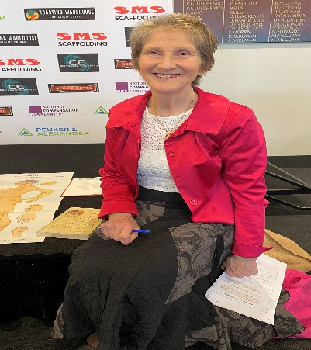
Monday Speaker
Glenys Savage, a Chinese medicine practitioner, lecturer and Tai Chi instructor.

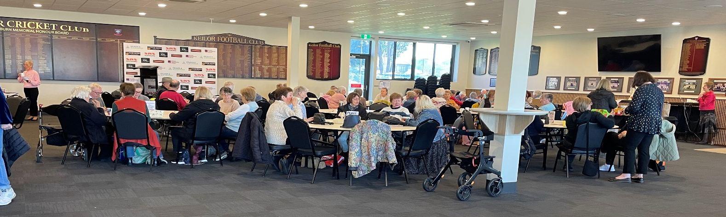


Theatre

Show | Event Date | Theatre | Payment Dates | Cost
Fiddler on the Roof | 11th November 2026 1.00 pm  1.00pm | Her Majesty’s Theatre | 14th September | $90
Mrs Doubtfire | 27th January 2027 | Princess Theatre | 23rd November | $90
The Castle on Stage | 21st April 2027 | Her Majesty’s Theatre | 22nd February | $90

What this space! LION KING and MATILDA 2027
NB The theatre ticket prices are Pensioner / Concession Rates – payments must be paid by due dates


Dine Out
Venue | Date | Time | Address
Cross Keys Hotel  Remember those days!!!! | Friday 18th September 2026 | 12.30 pm | 350 Pascoe Vale Road  Essendon

Book Table Update
Our Book Table has been doing very well this year. As many of you know, I usually take books that have been on the table for 4–6 months to Helping Hands and the Men’s Shed Library at Airport West.
Recently, I became aware of The Book Grocer, which buys books in good condition. Last month we had a number of books that had been on the table for 4–6 months, so I decided to try this option. I sent in 79 books and received $75.00, which will be donated to the Royal Children’s Hospital.

On a personal note, I also enjoy reading some of the books on the table. A few of you have told me, “That’s a good book,” even though it isn’t usually the kind of book I would read. Thank you to everyone who has broadened my reading horizons.
Thank you to everyone who donates and purchases books—your support makes a real difference.
Georgina

Monday 10.00 am- 2.00 pm
coffee/tea/chat
Register for outings/activities/special events
1st Monday of Month Hip Hop 12.00 pm/ Bingo 11.00am
2nd Monday Month Members Draw / Hip Hop 12.00 / Trivia
3rd Monday Month Trading Table/ Books / Raffles /Bingo / Hip Hop 12.00 pm
4th Monday Speaker (as advertised) /Trivia / /Hip Hop 12.00 pm
MONDAY
Ukulele – 9.30 am Judy Waterhouse 0438 142 700
Hip Hop – 12.00 pm – Jenny 0417 569 495
TUESDAY
Golf – 9.30am for 10.00am start (Keilor Golf Course) Convener: Mark Lipplegoes 0415 356 259
Assistant Golf Convener: Graeme Smith 0423 154 428
Meditation in Motion – 10.00 am Convener: Kerry Pollock 0409 792 654
Yoga– 11.15 am Convener: Glenys Adams 0414 757n632
Latin Lovers Line Dancing – 12.30 pm July Convener: TBA Joan 0408 362 697
WEDNESDAY
Chorus Line – 10.00-11.00am – Convener: Vivian Scarr 0417 120 069
Walking Football- (Keilor B Stadium) 1.00- 2.00pm Convener: Richard de Gabriele 0438 901144
Live Theatre - Norma Cocks – 0407 097 216
THURSDAY
Thursday Tai Chi – 10.00 – 11.00 am Convener: Georgina Hall 0418 124 890
Bike Riding – 10.00am Convener: Judy Waterhouse 0438 142 700
Walking Basketball – (Keilor Basketball Stadium) 11.30 – 12.30
FRIDAY
Nordic Walking/Walking (Brimbank Park) 9.30-10.30am Convener: Jill Kriechbaum 0431 182 713
Social Coffee and Chat (Brimbank Park) 10.30 am meet the walkers at the end of their walk, they may inspire you.
Dine-Outs - Maria Rizzas – 0407 865 075
SATURDAY
Early Bird Breakfast (Slices) 9.30am Convener: Kerrie Hallows 0415 133 554 (Last Saturday of month)

Contacts
Website Master – Trevor Withers -t.withers47@bigpond.com
Purchasing Officer – Georgina Hall - 0418 124 890
Bus Trips – Dianne Robinson – 0438 242 512
Club Uniforms –Glenys Adams - 0414 757 632
Trading Table – Sandra Bennett – 0452 366 380

Debit Details For any Payments
Direct Debit: MUST include description
BSB No. 063 591
Account No. 10137201 Name: Keilor Life Activities Club Inc.

September 2026

*Life Activities (LA) These are the weekly activities held in our club rooms. Check the activity sheet to visit outdoor / off site activities.

Monday | Tuesday | Wednesday | Thursday | Friday
 | 1 | 2 | 3 | 4
 | 9.30-2.00 pm - (LA)  10.00am Meditation  11.15 am Yoga  12.30pm Latin dancing | 8.30-12.00 pm - (LA)  10am - Chorus Line | 9.00-11.30 - (LA)  9.30 am -Tai Chi
7 | 8 | 9 | 10 | 11
8.00-2.00- (LA)  Bingo / Raffles  12.00 pm Hip Hop | 9.30-2.00 pm - (LA)  10.00am Meditation  11.15 am Yoga  12.30pm Latin dancing | 8.30-12.00 pm -(LA)  10am - Chorus Line | 9.00-11.30 - (LA)  9.30 am -Tai Chi
14 | 15 | 16 | 17 | 18
8.00-2.00 – (LA)  Trivia 11.00 am  9.30am  Committee Meeting | 9.30-2.00 pm -(LA)  10.00am Meditation  11.15 am Yoga  12.30pm Latin dancing | 8.30-12.00 pm (LA)  10am - Chorus Line | 9.00-11.30 - (LA)  9.30 am -Tai Chi
21 | 22 | 23 | 24 | 25
8.00-2.00- (LA)  Trading Table  Bingo / Raffles  12.00 pm Hip Hop | 9.30-2.00 pm -(LA)  10.00am Meditation  11.15 am Yoga  12.30pm Latin dancing | 8.30-1200 pm - (LA)  10am - Chorus Line | 9.00-11.30 - (LA)  9.30 am -Tai Chi
28 | 29 | 30
8.00-2.00- (LA)  Trivia 11.00 am  12.00 pm Hip Hop | 9.30-2.00pm -(LA)  10.00am Meditation  11.15 am Yoga  12.30pm Latin dancing | 8.30-12.00 pm - (LA)  10am - Chorus Line | 9.00-11.30 - (LA)  9.30 am -Tai Chi

