August 2026

P.O Box 99 Keilor 3036 www.keilorlife.com

Visit our Club Rooms Keilor Sports Club!

President  Joan Ellis  Mob: 0408 362 697  Jel48981@bigpond.net.au | Secretary  Glenys Adams -  Mob: 0414 757 632  admin@keilorlife.com | Web Master  Trevor Withers  t.withers47@bigpond.com  Carer  Judith Cave – Mob: 0408 301 057
Vice-President  Judith Cave  Mob:0408 301 057  info@keilorlife.com | Treasurer  Sue Lovell  Mob: 0402 056 070  Assistant Treasurer  Neil Webster  Neil13web@aol.com | Membership Secretary  Elizabeth Dowsett  Mob: 0481 008 462  Photographer  Dianne Robinson  Mob: 0438 242 512

Presidents Report August 2026

This month is our Annual General Meeting, (AGM). If you have thought about joining the governance team of our club, now is the time to come on board. It is rewarding in many ways. Allows you to build strong social connections and use your life skills to benefit the club / community while keeping mentally active. It offers a way to lead, advocate for older people adults and ensure vibrant programs for everyone involved.
Your personal benefits, build close friendships, stay intellectually engaged through planning, problem solving and organising events. Make a positive difference in the daily lives of fellow members.

Don’t just think about, give it ago.

Keep well,
Joan
“Challenges are what make life interesting and overcoming them is what makes life meaningful.”

Club Supporters
We gratefully acknowledge the ongoing support of:


Warwick Borello
Accountant Support

Fun in our clubrooms





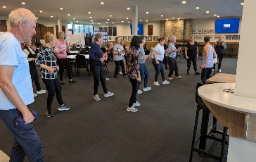




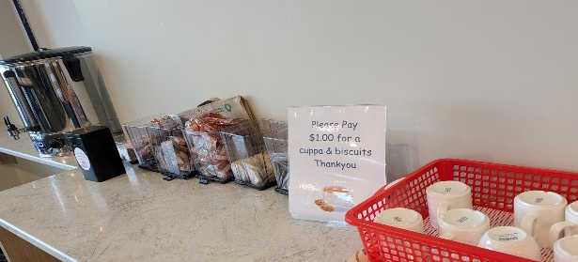
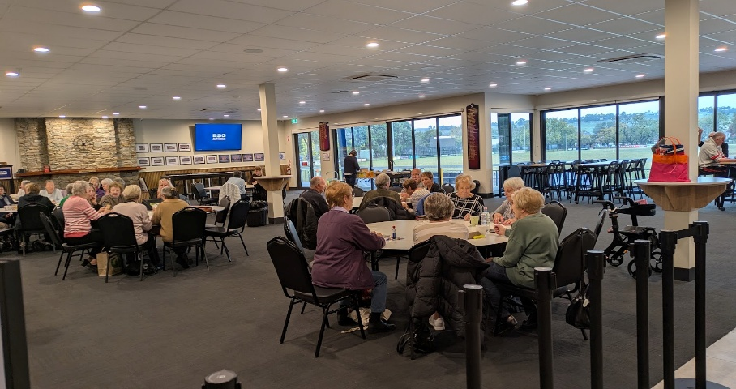



Theatre
Show | Payment Dates | Event Date | Theatre | Cost
A Beautiful Noise | Enjoy! | 19th August 2026 1.00 pm | The Princess
Six The Musical | closed | 2nd September 2026 1.00pm | Comedy Theatre | $80
Fiddler on the Roof | 14th September | 11th November 2026 | Her Majesty’s Theatre | $90

NB The theatre ticket prices are Pensioner / Concession Rates – payments must be paid by due dates
Dine Out

Venue | Date | Time | Address
Sugar Gum Hotel | Friday 21st August 2026 | 12.30 pm | Melton Highway

KLAC Members Monthly Draw
The lucky winners: -
July: what this space

Speaker: the topic: - “Eat for the seasons and keep fit, with traditional Chinese medicine, food, and Tai Chi.”
Speaker: Glenys Savage, a Chinese medicine practitioner, lecturer and Tai Chi instructor with 50 years’ experience.
TIME: 10.30 am – 11.00 am
DATE: Monday 17th August 2026
AGM:
24th August 2026 11.30am
Followed by light refreshments
Details page 6
Convener Meeting
Time: 11.00 am
Date; 31st August 2026
PLEASE NOTE!
The Tuesday programs have reverted to pre-July. Please check the time of the activity you are attending.

Monday 10.00 am- 2.00 pm
coffee/tea/chat
Register for outings/activities/special events
1st Monday of Month Hip Hop 12.00 pm/ Bingo 11.00am
2nd Monday Month Members Draw / Hip Hop 12.00 / Trivia
3rd Monday Month Trading Table/ Books / Raffles /Bingo / Hip Hop 12.00 pm
4th Monday Speaker (as advertised) /Trivia / /Hip Hop 12.00 pm
MONDAY
Ukulele – 9.30 am Judy Waterhouse 0438 142 700
Hip Hop – 12.00 pm – Jenny 0417 569 495
TUESDAY
Golf – 9.30am for 10.00am start (Keilor Golf Course) Convener: Mark Lipplegoes 0415 356 259
Assistant Golf Convener: Graeme Smith 0423 154 428
Meditation in Motion – 10.00 am Convener: Kerry Pollock 0409 792 654
Yoga– 11.15 am Convener: Glenys Adams 0414 757n632
Latin Lovers Line Dancing – 12.30 pm July Convener: TBA Joan 0408 362 697
WEDNESDAY
Chorus Line – 10.00-11.00am – Convener: Vivian Scarr 0417 120 069
Walking Football- (Keilor B Stadium) 1.00- 2.00pm Convener: Richard de Gabriele 0438 901144
Live Theatre - Norma Cocks – 0407 097 216
THURSDAY
Thursday Tai Chi – 10.00 – 11.00 am Convener: Georgina Hall 0418 124 890
Bike Riding – 10.00am Convener: Judy Waterhouse 0438 142 700
Walking Basketball – (Keilor Basketball Stadium) 11.30 – 12.30
FRIDAY
Nordic Walking/Walking (Brimbank Park) 9.30-10.30am Convener: Jill Kriechbaum 0431 182 713
Social Coffee and Chat (Brimbank Park) 10.30 am meet the walkers at the end of their walk, they may inspire you.
Dine-Outs - Maria Rizzas – 0407 865 075
SATURDAY
Early Bird Breakfast (Slices) 9.30am Convener: Kerrie Hallows 0415 133 554 (Last Saturday of month)

Contacts
Website Master – Trevor Withers -t.withers47@bigpond.com
Purchasing Officer – Georgina Hall - 0418 124 890
Bus Trips – Dianne Robinson – 0438 242 512
Club Uniforms –Glenys Adams - 0414 757 632
Trading Table – Sandra Bennett – 0452 366 380

Debit Details For any Payments
Direct Debit: MUST include description
BSB No. 063 591
Account No. 10137201 Name: Keilor Life Activities Club Inc.
August 2026
SUNDAY |  |  | MONDAY |  | TUESDAY |  | WEDNESDAY |  | THURSDAY |  | FRIDAY | SATURDAY
 | 26 | 27 |  | 28 |  | 29 |  | 30 |  | 31 |  | 1
 | 2 | 3 |  | 4 |  | 5 |  | 6 |  | 7 |  | 8
 |  |  | Life Activities 8.00-3.00  Bingo / Raffles  12.00 pm Hip Hop |  | Life Activities 9.30-2.30  Meditation 10.00am  Yoga 11.15 am  Latin dancing 1230 |  | Life Activities 8.30-12.30  Chorus Line 10.00am |  | Life Activities 9.00-11.30  Tai Chi 9.30 am
 | 9 | 10 |  | 11 |  | 12 |  | 13 |  | 14 |  | 15
 |  |  | Life Activities 8.00-3.00  Trivia 11.00 am  12.00 pm Hip Hop |  | Life Activities 9.30-2.30  Meditation 10.00am  Yoga 11.15 am  Latin dancing 1230 |  | Life Activities 8.30-12.30  Chorus Line 10.00am |  | Life Activities 9.00-11.30  Tai Chi 9.30 am
 | 16 | 17 |  | 18 |  | 19 |  | 20 |  | 21 |  | 22
 |  |  | Life Activities 8.00-3.00  Bingo / Raffles  Speaker 10.30 am  12.00 pm Hip Hop |  | Life Activities 9.30-2.30  Meditation 10.00am  Yoga 11.15 am  Latin dancing 1230 |  | Life Activities 8.30-12.30  Chorus Line 10.00am |  | Life Activities 9.00-11.30  Tai Chi 9.30 am
 | 23 | 24 |  | 25 |  | 26 |  | 27 |  | 28 |  | 29
 |  |  | Life Activities 8.00-3.00  Trivia 11.00 am  AGM 11.30am |  | Life Activities 9.30-2.30  Meditation 10.00am  Yoga 11.15 am  Latin dancing 1230 |  | Life Activities 8.30-12.30  Chorus Line 10.00am |  | Life Activities 9.00-11.30  Tai Chi 9.30 am
 | 30 | 31 |  | 1 |  | 2 |  | 3 |  | 4 |  | 5
 |  |  | Life Activities 8.00-3.00  Convene Meeting 11.00am |  | Meditation 10.00am  Yoga 11.15 am  Latin dancing 1230 |  | Chorus Line 10.00am

2026 AGM ELECTIONS
At the AGM to be held on the 24th August, 2026, elections will be held to fill the positions of Officers of the Club and Ordinary Committee Members. Positions are as follows: -
President Assistant Treasurer
Vice-President Newsletter Editor
Secretary Membership Secretary
Treasurer Ordinary Committee Members
[A document detailing the duties of each of the above positions is available from the Secretary]
- All current Club Officers and Ordinary Committee Members:
hold office until the 2026 AGM and are eligible for nomination and re-election
2. Those elected at the 2026 AGM will hold office until the 2027 AGM.
Call for Nominations
Nominations for the above positions are invited and must be made on the prescribed form [see below]
Completed forms, signed by two proposers and the person nominated, must reach The Secretary, KLAC P.O Box 99 Keilor, 3036 or may be handed to The Secretary, no less than seven [7] days prior to the 2026 AGM.
Business of the Meeting
- Confirm the minutes of the Annual General Meeting 25th August 2025
- Elect officers of the club.
- Receive and consider the Treasurer’s report.
- Appoint an auditor for the year 2026 / 2027
- President’s report.
Any special business of which notice has been given in accordance with the Rules of the Club.
-_______________________________________________________________________________________________
Keilor Life Activities Club Inc.
NOMINATION for CLUB OFFICERS AND ORDINARY COMMITTEE MEMBERS 2026/2027
We…………………………………………………….and ………………………………………………...
being financial members of the Keilor Life Activities Club Inc. hereby nominate:
Nominee………………………………………………………Position………………………………………
Signed………………………………………. Signed………………………………………...Date / /
Nominations are called for the following positions: President - Vice-President – Secretary -
Treasurer - Assistant Treasurer - Membership Secretary - Newsletter Editor - Ordinary Committee Members.
Completed Nomination forms must reach The Secretary, KLAC at P.O. Box 99, Keilor 3036 or handed to the Secretary no less then [7] days prior to the AGM Date - 24th August 2026.
Acceptance of Nomination:

I ……………………………………………. being a Financial Member of the Keilor Life Activities Club

Consent to my Nomination for the position of ……………………………………………….
[
Signed……….……………………………………. Phone ……………………………
Date……………………………………………………… Email…………………………………

