NEWSLETTER
July 2026

P.O Box 99 Keilor 3036 www.keilorlife.com
Visit our Club Rooms Keilor Sports Club! Old Calder Highway, Keilor 3036
Old Calder Highway, Keilor

August 2025
Club Rooms are Keilor Sports Club.
Old Calder Highway, Keilor
Club Patrons: Tony and Warwick Borello

President  Joan Ellis  Mob: 0408 362 697  Jel48981@bigpond.net.au | Secretary  Glenys Adams -  Mob: 0414 757 632  admin@keilorlife.com | Web Master  Trevor Withers  t.withers47@bigpond.com  Carer  Judith Cave – Mob: 0408 301 057
Vice-President  Judith Cave  Mob:0408 301 057  info@keilorlife.com | Treasurer  Sue Lovell  Mob: 0402 056 070  Assistant Treasurer  Neil Webster  Neil13web@aol.com | Photographer  Dianne Robinson  Mob: 0438 242 512
Presidents Report July 2026
You may not enjoy winter, however, it is difficult not to enjoy the welcoming fire Kelvin has burning in our club rooms on a Monday morning. Thank you, Kelvin, from all of us.
Welcome to all the KLAC members who have come on board since the beginning of February 2026.
There are fifty – four (54) new members since we resumed in February. We hope you enjoy many activities with us.

Thank you to all the members for welcoming our new members. We are ever so fortunate to have the support from our instructors, Lucy, Ellen, Jenny, Dianne, Maria and Yong. They are very inclusive people, making sure our new members are welcomed and feel comfortable in the activities they have chosen.
A big hug and best wishes to Lucy, (our chair aerobics instructor) who is recovering from surgery. We miss you and wish you a speedy recovery.
Please note on the second and fourth Monday of the month we will have trivia at 11.00 am.
A reminder to all members, August is the KLAC AGM.
If you are interested in the governance of our club, this is the time to join the committee.
Keep warm and well,
Joan

Club Supporters

We gratefully acknowledge the ongoing support of: 
Warwick Borello
Accountant Support

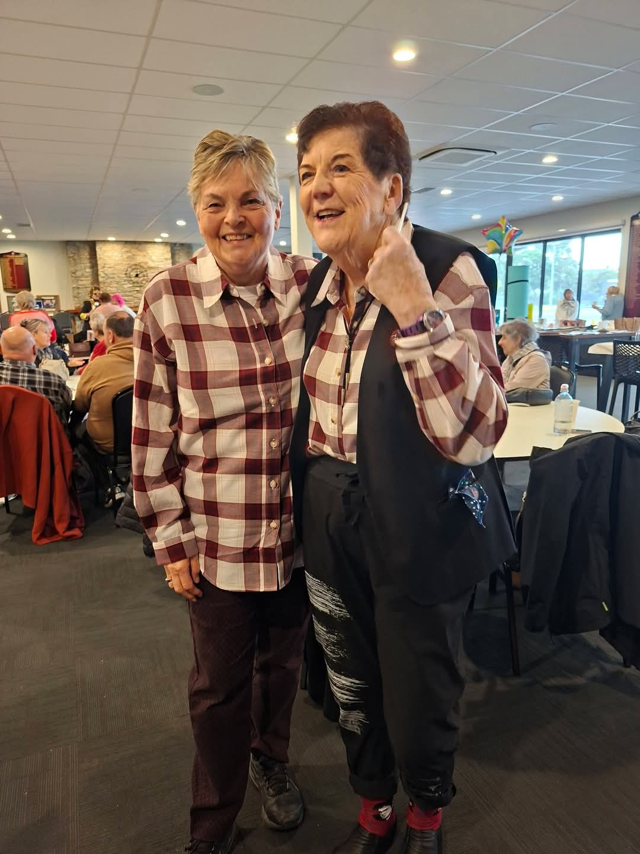
Fun in our clubrooms
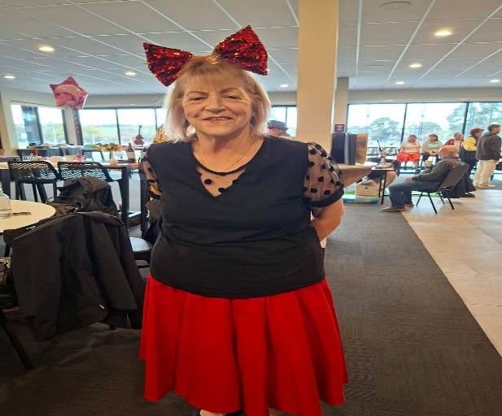



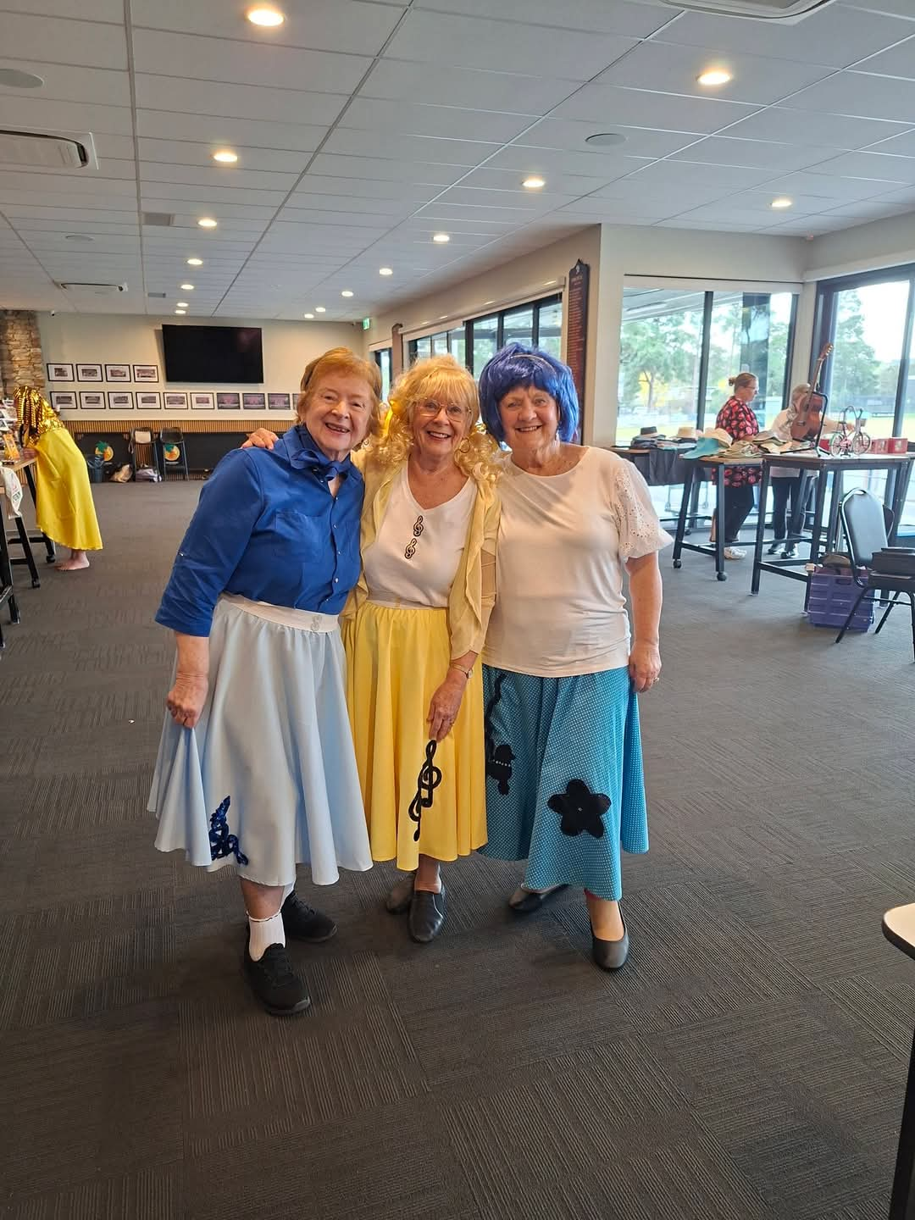

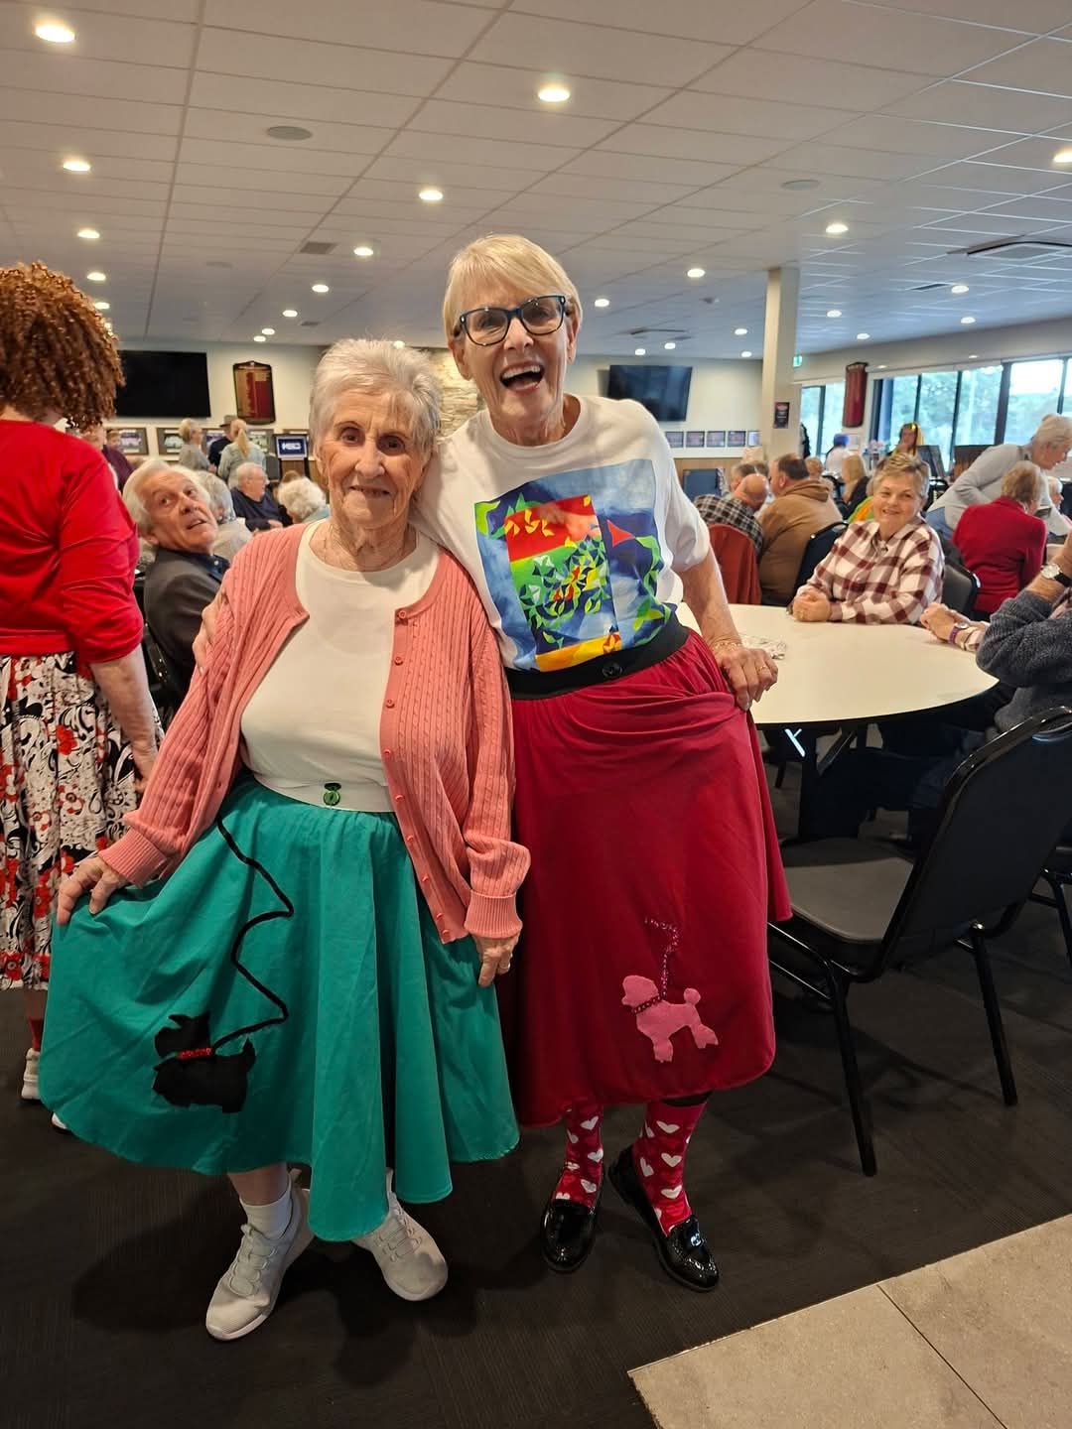



Theatre
Show | Payment Dates | Event Date | Theatre | Cost
Pretty Women | closed | 22nd July 2026 1.00pm | The Regent
A Beautiful Noise | closed | 19th August 2026 1.00 pm | The Princess | $90
Six The Musical | closed | 2nd September 2026 1.00pm | Comedy Theatre | $80
Fiddler on the Roof | 14th September | 4th November 2026 | Her Majesty’s Theatre | $90

NB The theatre ticket prices are Pensioner / Concession Rates – payments must be paid by due dates
Dine Out

Venue | Date | Time | Address
Pacinos Italian Restaurant | Friday 17th July 2026 | 12.30 pm | 300 Epsom Road Flemington

KLAC Members Monthly Draw
The lucky winners: -
May: Phillip Barr
June: Maria Rizzas


PLEASE NOTE
Yong, our Meditation and Yoga instructor will be on leave for the month of
July. The Tuesday Program: -
12.00pm Chair Yoga
1.00 pm Latin Line Dancing

These times are for the month of July 2026

Monday 10.00 am- 2.00 pm
coffee/tea/chat
Register for outings/activities/special events
1st Monday of Month Hip Hop 12.00 pm/ Bingo 11.00am
2nd Monday Month Members Draw / Hip Hop 12.00 / Trivia
3rd Monday Month Trading Table/ Books / Raffles /Bingo / Hip Hop 12.00 pm
4th Monday Speaker (as advertised) /Trivia / /Hip Hop 12.00 pm
MONDAY
Ukulele – 9.30 am Judy Waterhouse 0438 142 700
Hip Hop – 12.00 pm – Jenny 0417 569 495
TUESDAY
Golf – 9.30am for 10.00am start (Keilor Golf Course) Convener: Mark Lipplegoes 0415 356 259
Assistant Golf Convener: Graeme Smith 0423 154 428
Meditation in Motion – Resumes August 2026 Convener: Kerry Pollock 0409 792 654
Chair Yoga– 12.00 pm Convener: Glenys Adams 0414 757n632
Latin Lovers Line Dancing – 1.00 pm July Convener: TBA Joan 0408 362 697
WEDNESDAY
Chorus Line – 10.00-11.00am – Convener: Vivian Scarr 0417 120 069
Walking Football- (Keilor B Stadium) 1.00- 2.00pm Convener: Richard de Gabriele 0438 901144
Live Theatre - Norma Cocks – 0407 097 216
THURSDAY
Thursday Tai Chi – 10.00 – 11.00 am Convener: Georgina Hall 0418 124 890
Bike Riding – 10.00am Convener: Judy Waterhouse 0438 142 700
Walking Basketball – (Keilor Basketball Stadium) 11.30 – 12.30
FRIDAY
Nordic Walking/Walking (Brimbank Park) 9.30-10.30am Convener: Jill Kriechbaum 0431 182 713
Social Coffee and Chat (Brimbank Park) 10.30 am meet the walkers at the end of their walk, they may inspire you.
Dine-Outs - Maria Rizzas – 0407 865 075
SATURDAY
Early Bird Breakfast (Slices) 9.30am Convener: Kerrie Hallows 0415 133 554 (Last Saturday of month)

Contacts
Website Master – Trevor Withers -t.withers47@bigpond.com
Purchasing Officer – Georgina Hall - 0418 124 890
Bus Trips – Dianne Robinson – 0438 242 512
Club Uniforms –Glenys Adams - 0414 757 632
Trading Table – Sandra Bennett – 0452 366 380

Debit Details For any Payments
Direct Debit: MUST include description
BSB No. 063 591
Account No. 10137201 Name: Keilor Life Activities Club Inc.
JULY 2026
These are the weekly activities
Held in our club rooms
SUNDAY |  | MONDAY | TUESDAY | WEDNESDAY | THURSDAY | FRIDAY | SATURDAY
 | 28 | 29 | 30 | 1 | 2 | 3 | 4
 |  |  |  | Life Activities  8.30-12.30  Chorus Line | Life Activities  9.00-11.30  Tai Chi
 | 5 | 6 | 7 | 8 | 9 | 10 | 11
 |  | Life Activities 8.00-3.00  Bingo / Raffles  12.00 pm Hip Hop | Life Activities  11.00 – 2.00  Chair Yoga  Latin Line dancing | Life Activities  8.30-12.30  Chorus Line | Life Activities  9.00-11.30  Tai Chi
 | 12 | 13 | 14 | 15 | 16 | 17 | 18
 |  | Life Activities 8.00-3.00  Trivia  12.00 pm Hip Hop | Life Activities  11.00 – 2.00  Chair Yoga  Latin Line dancing | Life Activities 8.30-12.30  Chorus Line | Life Activities  9.00-11.30  Tai Chi
 | 19 | 20 | 21 | 22 | 23 | 24 | 25
 |  | Life Activities 8.00-3.00  Bingo / Raffles  12.00 pm Hip Hop | Life Activities –  11.00 – 2.00  Chair Yoga  Latin Line dancing | Life Activities 8.30-12.30  Chorus Line | Life Activities  9.00-11.30  Tai Chi
 | 26 | 27 | 28 | 29 | 30 | 31 | 1
 |  | Life Activities 8.00-3.00  Trivia  12.00 pm Hip Hop | Life Activities  11.00 – 2.00  Chair Yoga  Latin Line dancing | Life Activities  8.30-12.30  Chorus Line | Life Activities  9.00-11.30  Tai Chi

