NEWSLETTER
June / July 2026

P.O Box 99 Keilor 3036 www.keilorlife.com
Visit our Club Rooms Keilor Sports Club! Old Calder Highway, Keilor 3036
Old Calder Highway, Keilor

August 2025
Club Rooms are Keilor Sports Club.
Old Calder Highway, Keilor
Club Patrons: Tony and Warwick Borello

President  Joan Ellis  Mob: 0408 362 697  Jel48981@bigpond.net.au | Secretary  Glenys Adams -  Mob: 0414 757 632  admin@keilorlife.com | Web Master  Trevor Withers  t.withers47@bigpond.com  Carer  Judith Cave – Mob: 0408 301 057
Vice-President  Judith Cave  Mob:0408 301 057  info@keilorlife.com | Treasurer  Sue Lovell  Mob: 0402 056 070  Assistant Treasurer  Neil Webster  Neil13web@aol.com | Photographer  Dianne Robinson  Mob: 0438 242 512

Presidents Report June 2026
I am sorry you missed the May newsletter; we did not write one, due to lack of time. Our club activities keep us all happy, healthy, busy and time poor. While talking about the newsletter, please, send through activity information / photos or general information that we can print, and all learn from.
When you receive this newsletter, I hope most of you have attended our club rooms attending KLAC 2026 Expo. Each year this is a great opportunity to check out activities, meet people and catch up with stories and people from the past. It never ceases to amaze me the members of our club who, reunite after many years, in our club rooms.
Thank you to our conveners who have given extra time organising their activity stand for our expo and to the fitness instructors who have worked hard organising members into their activity display.
As winter sets in we need to keep away the “winter blues” with company. This is a good time to come to a club activity, bringing a friend or a neighbour who is about to hibernate. It is not good for us physically or mentally to become inactive.
Keep warm and well,
Joan

"The best thing about getting older is that you don't lose all the other ages you've been."

Club Supporters

We gratefully acknowledge the ongoing support of: 
Warwick Borello
Accountant Support

Bus Trip – 5 Days to the high country staying in Bright.

They are back! Happy and healthy.
From the stories we have been told and the knowledge that they are going back next year means they have had a marvellous trip. We have also noted that the food was good and in abundance increasing the members attending our exercise classes on return.
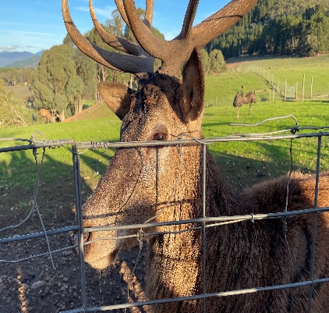
A great trip was had by all. The hospitality from all at the Bright Chalet was tops. Hope to see you all there next year - Dianne

Thank you! to Dianne who never lets our club down, choosing trips for all to enjoy, caring for all member’s needs.




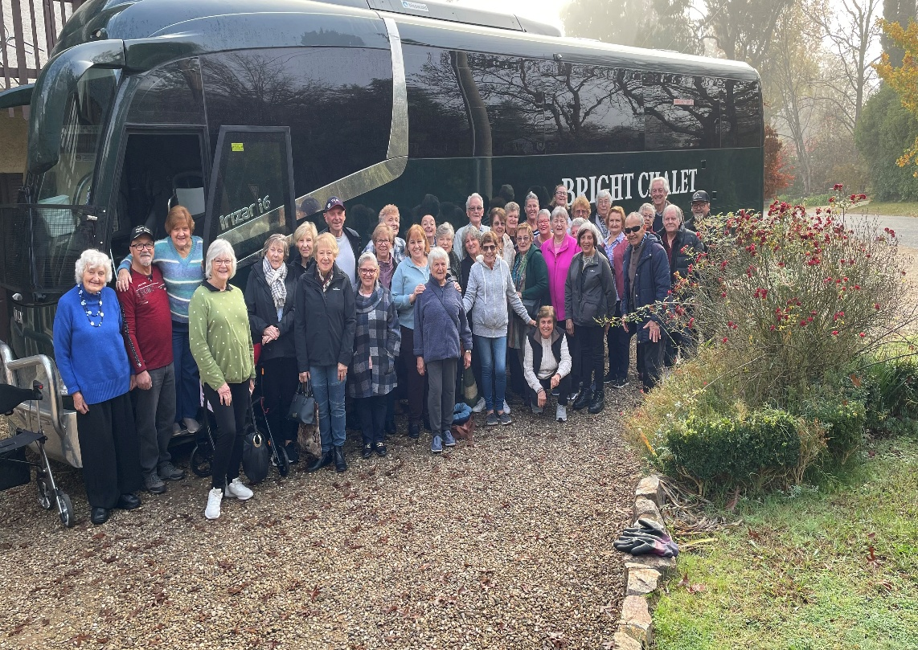

Theatre
Show | Payment Dates | Event Date | Theatre | Cost
Pretty Women |  | 22nd July 2026 1.00pm | The Regent
A Beautiful Noise | 15th June | 19th August 2026 1.00 pm | The Princess | $90
Six The Musical | 29th June | 2nd September 2026 1.00pm | Comedy Theatre | $80
Fiddler on the Roof | 14th September | 4th November 2026 | Her Majesty’s Theatre | $90

NB The theatre ticket prices are Pensioner / Concession Rates – payments must be paid by due dates
Dine Out

Venue | Date | Time | Address
Green Gully Reserve Bistro | Friday 19th June 2026 | 12.30 pm | 151 Club House Place, Keilor Downs



PLEASE NOTE
Yong, our Meditation and Yoga instructor will be on leave for the month of
July. Please contact Glenys 0414 757 632 for activity suggestions to fill in the time Yong is away. Thank you, keep well and warm.

Monday 10.00 am- 2.00 pm
coffee/tea/chat
Register for outings/activities/special events
1st Monday of Month Chair Aerobics 12.00 pm/ Bingo 11.00am
2nd Monday Month Members Draw / Hip Hop 12.00
3rd Monday Month Trading Table/ Books / Raffles /Bingo / Hip Hop 12.00 pm
4th Monday Speaker (as advertised) / Hip Hop 12.00
MONDAY
Ukulele – 9.30 am Judy Waterhouse 0438 142 700
Hip Hop – 12.00 pm – Jenny 0414 757 632
TUESDAY
Golf – 9.30am for 10.00am start (Keilor Golf Course) Convener: Mark Lipplegoes 0415 356 259
Assistant Golf Convener: Graeme Smith 0423 154 428
Meditation in Motion - 10.00 am – 11.00 am Convener: Kerry Pollock 0409 792 654
Yoga for all abilities – 11.15am Convener: Glenys Adams. All abilities yoga can be mat on the floor, in a walking frame / wheelchair or on chair. Where you are most comfortable.
Latin Lovers Line Dancing – 12.30pm Convener: TBA Joan 0408 362 697
WEDNESDAY
Chorus Line – 10.00-11.00am – Convener: Vivian Scarr 0417 120 069
Walking Football- (Keilor Basketball Stadium) 1.00- 2.00pm Convener: TBA
Live Theatre - Norma Cocks – 0407 097 216
THURSDAY
Thursday Tai Chi – 10.00 – 11.00 am Convener: Georgina Hall 0418 124 890
Bike Riding – 10.00am Convener: Judy Waterhouse 0438 142 700
Walking Basketball – (Keilor Basketball Stadium) 11.30 – 12.30
FRIDAY
Nordic Walking/Walking (Brimbank Park) 9.30-10.30am Convener: Jill Kriechbaum 0431 182 713
Social Coffee and Chat (Brimbank Park) 10.30 am meet the walkers at the end of their walk, they may inspire you.
Dine-Outs - Maria Rizzas – 0407 865 075
SATURDAY
Early Bird Breakfast (Slices) 9.30am Convener: Kerrie Hallows 0415 133 554 (Last Saturday of month)

Contacts
Website Master – Trevor Withers -t.withers47@bigpond.com
Purchasing Officer – Georgina Hall - 0418 124 890
Bus Trips – Dianne Robinson – 0438 242 512
Club Uniforms –Glenys Adams - 0414 757 632
Trading Table – Sandra Bennett – 0452 366 380

Debit Details For any Payments
Direct Debit: MUST include description
BSB No. 063 591
Account No. 10137201 Name: Keilor Life Activities Club Inc.
JUNE 2026
These are the weekly activities
Held in our club rooms
SUNDAY |  | MONDAY | TUESDAY | WEDNESDAY | THURSDAY | FRIDAY | SATURDAY
 | 31 | 1 | 2 | 3 | 4 | 5 | 6
 |  | Life Activities 8.00-3.00  KLAC EXPO  11.00 am – 1.00pm | Life Activities 9.30-2.30  Meditation  Yoga  Latin Line dancing | Life Activities 8.30-12.30  Chorus Line | Life Activities 9.00-11.30  Tai Chi
 | 7 | 8 | 9 | 10 | 11 | 12 | 13
 |  | King’s Birthday | Life Activities 9.30-2.30  Meditation  Yoga | Life Activities 8.30-12.30  Chorus Line | Life Activities 9.00-11.30  Tai Chi  Tai Chi
 | 14 | 15 | 16 | 17 | 18 | 19 | 20
 |  | Life Activities 8.00-3.00  Bingo / Raffles  12.00 pm Hip Hop | Life Activities 9.30-2.30  Meditation  Yoga  Latin Line dancing | Life Activities 8.30-12.30  Chorus Line | Life Activities 9.00-11.30  Tai Chi  Tai Chi
 | 21 | 22 | 23 | 24 | 25 | 26 | 27
 |  | Life Activities 8.00-3.00  12.00 pm Hip Hop | Life Activities 9.30-2.30  Meditation  Yoga  Latin Line dancing | Life Activities 8.30-12.30  Chorus Line | Life Activities 9.00-11.30  Tai Chi
 | 28 | 29 | 30 | 1 | 2 | 3 | 4
 |  | Life Activities 8.00-3.00  12.00 pm Hip Hop | Life Activities 9.30-2.30  Meditation  Yoga  Latin Line dancing

JULY 2026
These are the weekly activities
Held in our club rooms
SUNDAY |  | MONDAY | TUESDAY | WEDNESDAY | THURSDAY | FRIDAY | SATURDAY
 | 28 | 29 | 30 | 1 | 2 | 3 | 4
 |  |  |  | Life Activities  8.30-12.30  Chorus Line | Life Activities  9.00-11.30  Tai Chi
 | 5 | 6 | 7 | 8 | 9 | 10 | 11
 |  | Life Activities 8.00-3.00  Bingo / Raffles  12.00 pm Hip Hop | Life Activities  12.15 – 1.30  Latin Line dancing | Life Activities  8.30-12.30  Chorus Line | Life Activities  9.00-11.30  Tai Chi
 | 12 | 13 | 14 | 15 | 16 | 17 | 18
 |  | Life Activities 8.00-3.00  12.00 pm Hip Hop | Life Activities  12.15 – 1.30  Latin Line dancing | Life Activities 8.30-12.30  Chorus Line | Life Activities  9.00-11.30  Tai Chi
 | 19 | 20 | 21 | 22 | 23 | 24 | 25
 |  | Life Activities 8.00-3.00  Bingo / Raffles  12.00 pm Hip Hop | Life Activities -  12.15 – 1.30  Latin Line dancing | Life Activities 8.30-12.30  Chorus Line | Life Activities  9.00-11.30  Tai Chi
 | 26 | 27 | 28 | 29 | 30 | 31 | 1
 |  | Life Activities 8.00-3.00  12.00 pm Hip Hop | Life Activities  12.15 – 1.30  Latin Line dancing | Life Activities  8.30-12.30  Chorus Line | Life Activities  9.00-11.30  Tai Chi


