NEWSLETTER
April 2026

P.O Box 99 Keilor 3036 www.keilorlife.com
Visit our Club Rooms Keilor Sports Club! Old Calder Highway, Keilor 3036
Old Calder Highway, Keilor

August 2025
Club Rooms are Keilor Sports Club.
Old Calder Highway, Keilor
Club Patrons: Tony and Warwick Borello

President  Joan Ellis  Mob: 0408 362 697  president@keilorlife.com | Secretary  Glenys Adams -  Mob: 0414 757 632  admin@keilorlife.com | Web Master  Trevor Withers  t.withers47@bigpond.com  Carer  Judith Cave – Mob: 0408 301 057
Vice-President  Judith Cave  Mob:0408 301 057  info@keilorlife.com | Treasurer  Sue Lovell  Mob: 0402 056 070  Assistant Treasurer  Neil Webster  Neil13web@aol.com | Photographer  Dianne Robinson  Mob: 0438 242 512
Presidents Report April 2026
I hope everyone has enjoyed a peaceful Easter and consumed all the traditional Easter delights.
Thank you to the generous members who gave their time, unconditionally, at a Bunnings Sausage Sizzle, Easter Monday. Bunnings contributions are major revenue for KLAC. Sometimes we forget and think the activity we participate in, is the entire club, we must all remember, we have twenty activities and we are all one club KLAC. The Bunnings Sizzles support, allow us to trial new activities, subsidise special events and is spread across all club activities.
This year we have started three classes on Tuesday. Meditation in Motion, Yoga for All Abilities (members can use a mat, chair, walking frame), Latin Lovers Line Dancing. Tuesday is a very friendly happy day. Members are staying for one, two or three classes. They enjoy a cuppa and chatter between each class. New friendships, exercise, laughter, jokes, it is all happening. I am so proud that our club has never lost its welcoming spirit.
1st June, we will hold our KLAC Expo, showcasing our club and all our activities. Visitors will be welcome to visit and enjoy what we have to show off.
Keep warm and well,
Joan
“Happiness is not something ready-made. It comes from your own actions.”

Club Supporters

We gratefully acknowledge the ongoing support of: 
Warwick Borello
Accountant Support

Speaker
11th May 2026
11.00 am Topic: Financial Information and Age pension
Centrelink will have a representative along. You are welcome to bring a friend.

Libraries After Dark: Pop Culture Trivia Night
Follow
Part of the Libraries After Dark collection
Brimbank Libraries: St Albans Library St Albans, VIC
Thursday 23 April • 18 - 19:30

Age range:
- This event is for Adults & Families.

Event Info:
Are you a trivia champ? Test your knowledge with our pop culture trivia night - books, general knowledge and who's who in the world of pop culture.
Open to anyone over the age of 16. Book a team of two, a family of four or six friends! Flying solo? We’ll get you sorted into a team on the night!
Light refreshments will be available 30 minutes before workshop begins.

KLAC Members Monthly Draw
The lucky winner
March– Jeff Thompson
New Members Welcome! Enjoy KLAC’s many activities.
Jenny Chisholm Greg Cole Rina Millimaci Carmen Stefano Connie Manigiardi Judy Ellis
Jenny Ellis Dianne Tassone Noelene Wattie Alicja Jayesmica Nada Sustar
Welcome back to Margaret Jaensch

Dine Out

Venue | Date | Time | Address
Pacino’s Italian Restaurant | Friday May 15th 2026 | 12.30pm | 300 Epsom Road Flemington  Near the Showgrounds

Bus Trip – 5 Days
Trip to the beautiful high country staying in Bright.
Date: Leaving 25th May 2026 returning home 29th May 2026

Theatre
Show | Payment Dates | Event Date | Theatre | Cost
Waitress |  | 13th May 2026 1.00pm | Her Majesty’s
Pretty Women |  | 22nd July 2026 1.00pm | The Regent
A Beautiful Noise | 15th June | 19th August 2026 1.00 pm | The Princess | $90
Six The Musical | 29th June | 2nd September 2026 1.00pm | Comedy Theatre | $80
NB The theatre ticket prices are Pensioner / Concession Rates – payments must be paid by due dates
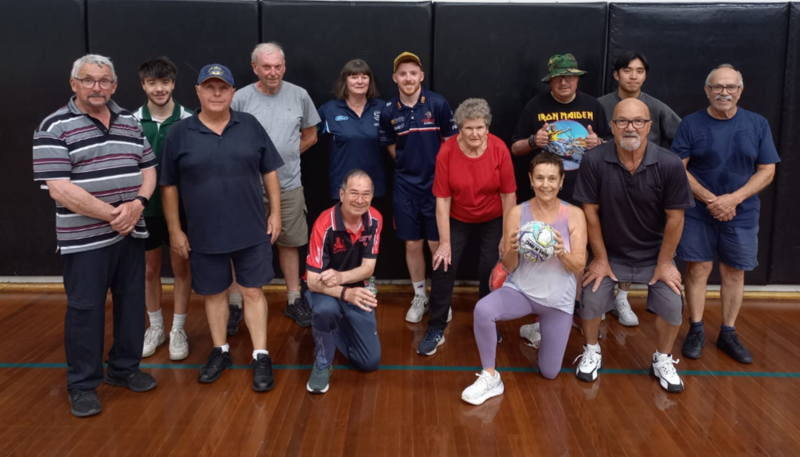
Walking Footballers
They certainly look a very competitive bunch. Thank you Richard Degabriele! He is our new convener for “Walking football”. Richard also attends our Tai Chi class. Well, done Richard. We encourage the men in our club to attend the many activities on offer.

Please! Would all activities send in reports funny, serious or? Our newsletter goes out to 210 plus homes. What you do might encourage community members to come and have some fun and interact with new friends.

NOTE TO THE MEN! What is it we can do to encourage more of the men in our club to participate in the many activities available. Is there something else you would like us to try? Please contact us.

Monday 10.00 am- 2.00 pm
coffee/tea/chat
Register for outings/activities/special events
1st Monday of Month Chair Aerobics 12.00 pm/ Bingo 11.00am
2nd Monday Month Members Draw / Hip Hop 12.00
3rd Monday Month Trading Table/ Books / Raffles /Bingo / Hip Hop 12.00 pm
4th Monday Speaker (as advertised) / Hip Hop 12.00
MONDAY
Ukulele – 9.30 am Judy Waterhouse 0438 142 700
Hip Hop – 12.00 pm – Jenny 0414 757 632
TUESDAY
Golf – 9.30am for 10.00am start (Keilor Golf Course) Convener: Mark Lipplegoes 0415 356 259
Assistant Golf Convener: Graeme Smith 0423 154 428
Meditation in Motion - 10.00 am – 11.00 am Convener: Kerry Pollock 0409 792 654
Yoga for all abilities – 11.15am Convener: Glenys Adams. All abilities yoga can be mat on the floor, in a walking frame / wheelchair or on chair. Where you are most comfortable.
Latin Lovers Line Dancing – 12.30pm Convener: TBA Joan 0408 362 697
WEDNESDAY
Chorus Line – 10.00-11.00am – Convener: Vivian Scarr 0417 120 069
Walking Football- (Keilor Basketball Stadium) 1.00- 2.00pm Convener: TBA
Live Theatre - Norma Cocks – 0407 097 216
THURSDAY
Thursday Tai Chi – 10.00 – 11.00 am Convener: Georgina Hall 0418 124 890
Bike Riding – 10.00am Convener: Judy Waterhouse 0438 142 700
Walking Basketball – (Keilor Basketball Stadium) 11.30 – 12.30
FRIDAY
Nordic Walking/Walking (Brimbank Park) 9.30-10.30am Convener: Jill Kriechbaum 0431 182 713
Social Coffee and Chat (Brimbank Park) 10.30 am meet the walkers at the end of their walk, they may inspire you.
Dine-Outs - Maria Rizzas – 0407 865 075
SATURDAY
Early Bird Breakfast (Slices) 9.30am Convener: Kerrie Hallows 0415 133 554 (Last Saturday of month)

Contacts
Website Master – Trevor Withers -t.withers47@bigpond.com
Purchasing Officer – Georgina Hall - 0418 124 890
Bus Trips – Dianne Robinson – 0438 242 512
Club Uniforms –Glenys Adams - 0414 757 632
Trading Table – Sandra Bennett – 0452 366 380

Debit Details For any Payments
Direct Debit: MUST include description
BSB No. 063 591
Account No. 10137201 Name: Keilor Life Activities Club Inc.

APRIL 2026

SUNDAY |  | MONDAY | TUESDAY | WEDNESDAY | THURSDAY | FRIDAY | SATURDAY
 | 29 | 30 | 31 | 1 | 2 | 3 | 4
 |  |  |  |  |  | Good Friday
 | 5 | 6  NoN | 7 | 8 | 9 | 10 | 11
Easter Sunday |  | Easter Monday | Life Activities 9.30-2.30  Meditation  Yoga  Latin Line dancing | Life Activities 8.30-2.30  Chorus Line | Life Activities 9.00-11.30
 | 12 | 13 | 14 | 15 | 16 | 17 | 18
 |  | Life Activities 8.00-3.00 | Life Activities 9.30-2.30  Meditation  Yoga  Latin Line dancing  KSC Meeting 7.30pm | Life Activities 8.30-2.30  Chorus Line | Life Activities 9.00-11.30  Tai Chi
 | 19 | 20 | 21 | 22 | 23 | 24 | 25
 |  | Life Activities 8.00-3.00  Trading Table  Bingo  HipHop  Raffle | Life Activities 9.30-2.30  Meditation  Yoga  Latin Line dancing | Life Activities 8.30-2.30  Chorus Line | Life Activities 9.00-11.30  Tai Chi
 | 26 | 27 | 28 | 29 | 30 | 1 | 2
 |  | Life Activities 8.00-3.00 | Life Activities 9.30-2.30  Meditation  Yoga  Latin Line dancing | Life Activities 8.30-2.30  Chorus Line | Life Activities 9.00-11.30  Tai Chi
 |  |  | MAY 2026
SUNDAY |  | MONDAY | TUESDAY | WEDNESDAY | THURSDAY | FRIDAY | SATURDAY
 | 26 | 27 | 28 | 29 | 30 | 1 | 2
 | 3 | 4 | 5 | 6 | 7 | 8 | 9
 |  | Life Activities 8.00-3.00  Mother’s Day Theme  Bingo | Life Activities 9.30-2.30  Meditation  Yoga  Latin Line dancing | Life Activities 8.30-12.30  Chorus Line | Life Activities 9.00-11.30  Tai Chi
 | 10 | 11 | 12 | 13 | 14 | 15 | 16
 |  | Life Activities 8.00-3.00  Speaker - Centrelink re finance & pensions | Life Activities 9.30-2.30  Meditation  Yoga  Latin Line dancing | Life Activities 8.30-12.30  Chorus Line | Life Activities 9.00-11.30  Tai Chi
 | 17 | 18 | 19 | 20 | 21 | 22 | 23
 |  | Life Activities 8.00-3.00  Trading Table  Bingo Raffles | Life Activities 9.30-2.30  Meditation  Yoga  Latin Line dancing | Life Activities 8.30-12.30  Chorus Line | Life Activities 9.00-11.30  Tai Chi
 | 24 | 25 | 26 | 27 | 28 | 29 | 30
 |  | Life Activities 8.00-3.00 | Life Activities 9.30-2.30  Meditation  Yoga  Latin Line dancing | Life Activities 8.30-12.30  Chorus Line | Life Activities 9.00-11.30  Tai Chi
 | 31 | 1 | 2 | 3 | 4 | 5 | 6


