NEWSLETTER
March 2026

P.O Box 99 Keilor 3036 www.keilorlife.com
Visit our Club Rooms Keilor Sports Club!
Old Calder Highway, Keilor

August 2025
Club Rooms are Keilor Sports Club.
Old Calder Highway, Keilor
Club Patrons: Tony and Warwick Borello

President  Joan Ellis  Mob: 0408 362 697  president@keilorlife.com | Secretary  Glenys Adams -  Mob: 0414 757 632  admin@keilorlife.com | Web Master  Trevor Withers  t.withers47@bigpond.com  Carer  Judith Cave – Mob: 0408 301 057
Vice-President  Judith Cave  Mob:0408 301 057  info@keilorlife.com | Treasurer  Sue Lovell  Mob: 0402 056 070  Assistant Treasurer  Neil Webster  Neil13web@aol.com | Photographer  Dianne Robinson  Mob: 0438 242 512

Presidents Report March 2026
Thank you to all the members who sent through messages commenting on the lovely, happy day they had celebrating our 21st Birthday and what a great hit Elvis was. I agree it was a great day. It would be remiss of me not to thank the KLAC members for the gift I was presented with for being an achiever for KLAC. Thank you all, I appreciate your good wishes, however, it is not hard work, I love the club and what it does for our senior community.
23rd March 11.00 am (next Monday) this is the singalong with Vicki Jacobs from the Glee Club. Please make and effort to come along. You are welcome to bring a friend. The songs are from The Jersey Boys. A BIG thank you to Melbourne Airport, as a 21st Birthday present to KLAC, they are paying The Glee Club account.
Keep smiling,
Joan
“My mission in life is not only to enjoy life but to help others to feel the joy of life.”
Club Supporters
We gratefully acknowledge the ongoing support of:


Warwick Borello
Accountant Support

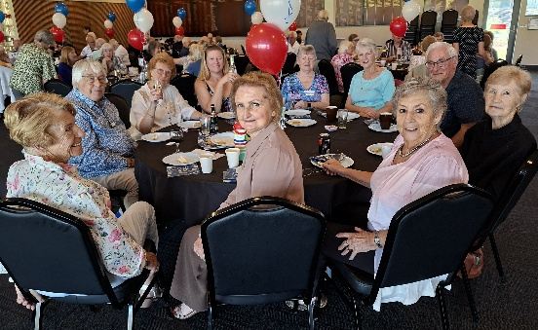
Happy faces at our 21st Birthday Celebration

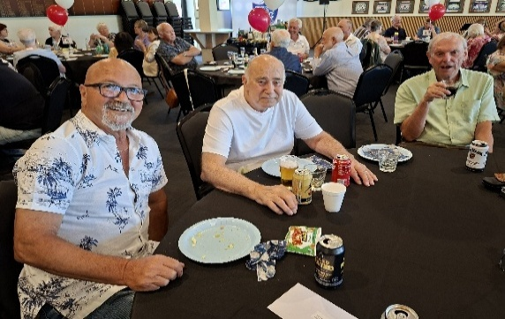
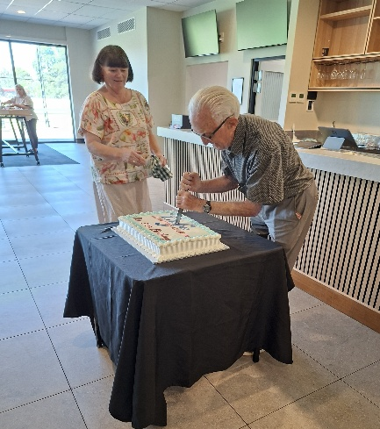
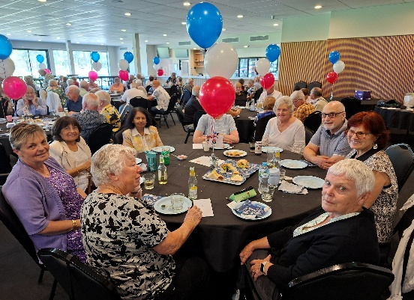


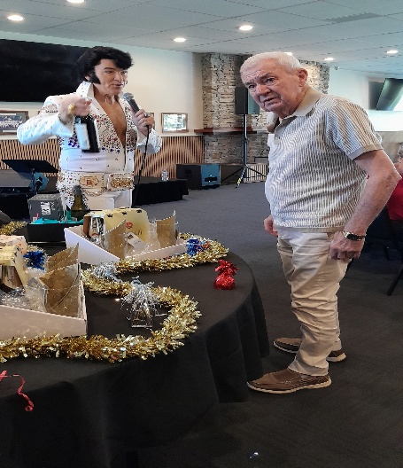
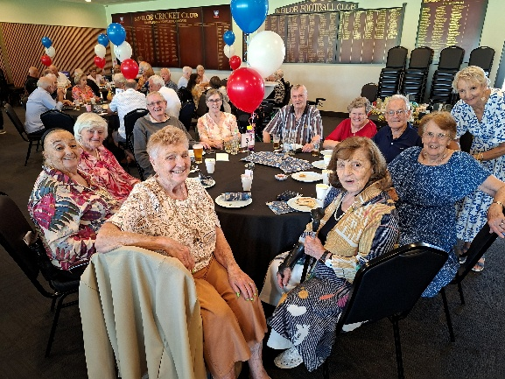

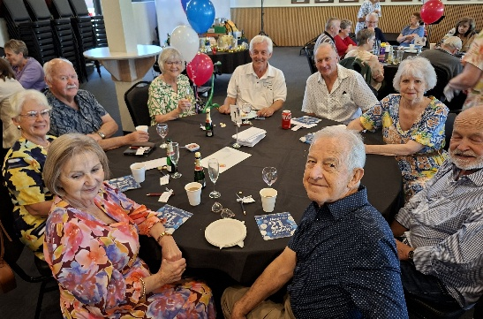
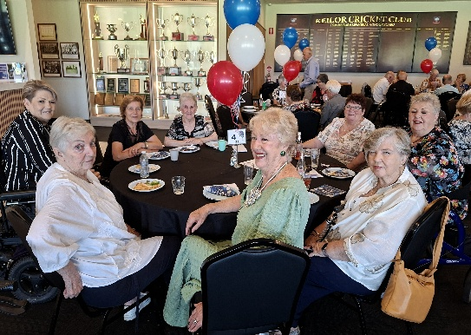


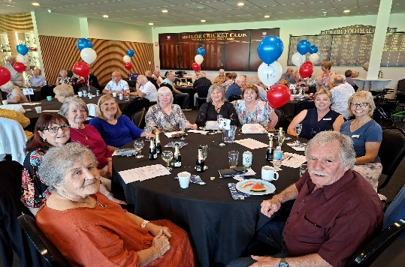
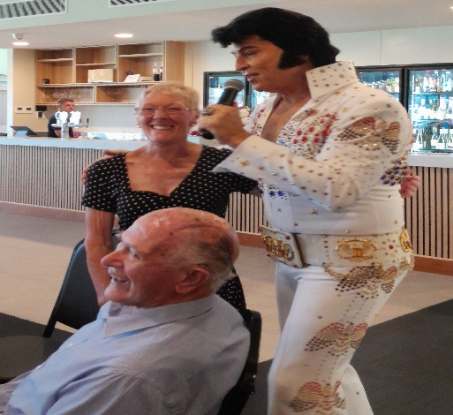
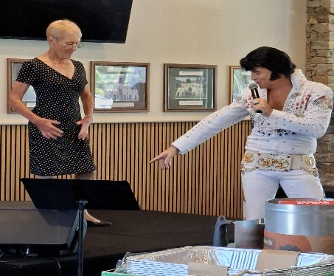



SCAM WARNING:
Pause before you click
- Urgent messages: Scammers create pressure with unpaid tolls, delivery issues or account warnings.
- Check the source: Go directly to the official website or app instead of using the link provided
- Look for red flags: Unexpected messages, spelling errors or unusual sender details
When in doubt: Don’t click, don’t reply, and delete the message

KLAC Members Monthly Draw
The lucky winner
March– draw 23/3/26
New Members Welcome! We hope you enhance your life with KLAC activities
Eva Doolan Gina Galea Michelle Bourke Eduardo Puente
Dine Out

Venue | Date | Time
Keilor Hotel | 20th March 2026 | 12.30pm

Bus Trip – 5 Days
Trip to the beautiful high country staying in Bright.
Date: Leaving 25th May 2026 returning home 29th May 2026

Theatre
Show | Payment Dates | Event Date | Theatre | Cost
Waitress | 30th March | 13th May 2026 1.00pm | Her Majesty’s | $70
Pretty Women | 23rd March | 22nd July 2026 1.00pm | The Regent | $90
A Beautiful Noise | 15th June | 19th August 2026 1.00 pm | The Princess | $90
Six The Musical | 29th June | 2nd September 2026 1.00pm | Comedy Theatre | $80
NB The theatre ticket prices are Pensioner / Concession Rates – payments must be paid by due dates

Wednesday 25th March 2026 10.00am – 2 pm
Brimbank Disability, Seniors and Carers Expo. – Keilor Basketball Netball Stadium – Keilor Park
I encourage all of you to find time and visit this expo. There will be 100 exhibitors. It is rare to find this wide range of services and supports all in one place. In fact there will be services you are unaware of. Go check it out.

Walking Football
Held every Wednesday 1 pm at the Keilor Basketball stadium. This is a fun and social way to stay active. You are very welcome to drop by, see how the game is played, and enjoy a cuppa after.
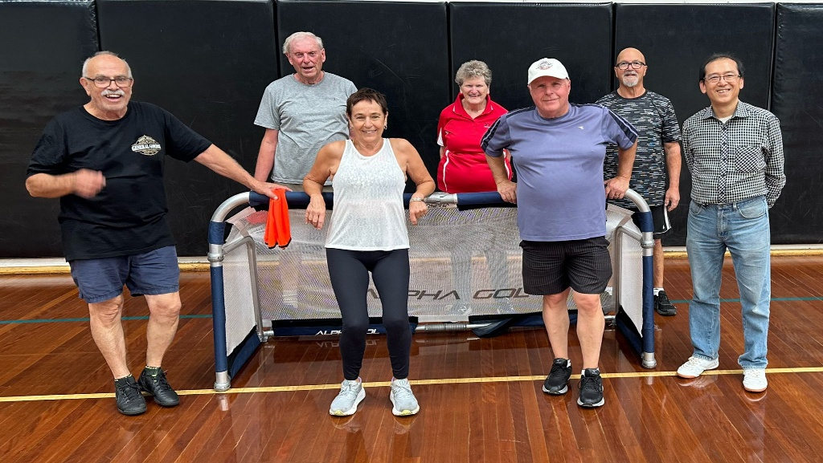
We are currently looking for a convener for this activity. If you would like to assist speak with Joan, our President or any committee member.

Nordic Walking

Join us every Friday morning at Brimbank Park, meeting in the large car park 9.15 am. You can choose between the long walk (includes some hills) or the short (on flat ground). Nordic walking sticks(supplied) can be used for either option.
The best comes afterwards- relaxing in the café with a cuppa and a great chat! Jill is the convener for this group, so please speak with her if you would like to join in or learn more.

Singalong with the lovely Vicki Jacobs as our host.
23rd March 11.00 am in our club rooms
Join us for a joyful Jersey Boys Singalong, celebrating the unforgettable hits of Frankie Valli and The Four Seasons!
Whether you’re a shower singer or a superstar, this is your chance to sing your heart out in a relaxed, welcoming environment. There are no solos, no auditions and no pressure, just a big group sing filled with great music and plenty of laughs.
Vicky Jacobs from Glee Club Singing has been hosting joyful singalongs for over 20 years and knows a thing or two about bringing the magic of Jersey Boys to life. You don’t need to prepare anything or even know the songs particularly well, we’ll give you everything you need on the day.
Come along, raise your voice and enjoy the magic of these timeless classics together.

Monday 10.00 am- 2.00 pm
coffee/tea/chat
Register for outings/activities/special events
1st Monday of Month Chair Aerobics 12.00 pm/ Bingo 11.00am
2nd Monday Month Members Draw / Hip Hop 12.00
3rd Monday Month Trading Table/ Books / Raffles /Bingo / Hip Hop 12.00 pm
4th Monday Speaker (as advertised) / Hip Hop 12.00
MONDAY
Ukulele – TBA – Judy Waterhouse 0438 142 700
Hip Hop – 12.00 pm – Jenny 0414 757 632
TUESDAY
Golf – 9.30am for 10.00am start (Keilor Golf Course) Convener: Mark Lipplegoes 0415 356 259
Assistant Golf Convener: Graeme Smith 0423 154 428
Meditation in Motion - 10.00 am – 11.00 am Convener: Kerry Pollock 0409 792 654
Yoga for all abilities – 11.15am Convener: Glenys Adams. All abilities yoga can be mat on the floor, in a walking frame / wheelchair or on chair. Where you are most comfortable.
Latin Lovers Line Dancing – 12.30pm Convener: TBA Joan 0408 362 697
WEDNESDAY
Chorus Line – 10.00-11.00am – Convener: Vivian Scarr 0417 120 069
Walking Football- (Keilor Basketball Stadium) 1.00- 2.00pm Convener: TBA
Live Theatre - Norma Cocks – 0407 097 216
THURSDAY
Thursday Tai Chi – 10.00 – 11.00 am Convener: Georgina Hall 0418 124 890
Bike Riding – 10.00am Convener: Judy Waterhouse 0438 142 700
Walking Basketball – (Keilor Basketball Stadium) 11.30 – 12.30
FRIDAY
Nordic Walking/Walking (Brimbank Park) 9.30-10.30am Convener: Jill Kriechbaum 0431 182 713
Social Coffee and Chat (Brimbank Park) 10.30 am meet the walkers at the end of their walk, they may inspire you.
Dine-Outs - Maria Rizzas – 0407 865 075
SATURDAY
Early Bird Breakfast (Slices) 9.30am Convener: Kerrie Hallows 0415 133 554 (Last Saturday of month)

Contacts
Website Master – Trevor Withers -t.withers47@bigpond.com
Purchasing Officer – Georgina Hall - 0418 124 890
Bus Trips – Dianne Robinson – 0438 242 512
Club Uniforms –Glenys Adams - 0414 757 632
Trading Table – Sandra Bennett – 0452 366 380

Debit Details For any Payments
Direct Debit: MUST include description
BSB No. 063 591
Account No. 10137201 Name: Keilor Life Activities Club Inc.
Cash payments
Payment table in KLAC Club Rooms
Payment Table closes at 11.30 am
MARCH 2026
These are the weekly activities
held In our Club Rooms
MONDAY | TUESDAY | WEDNESDAY | THURSDAY
2 | 3 | 4 | 5
 | Life Activities 9.30-2.30  Meditation  Yoga  Latin Line dancing | Life Activities 8.30-12.30  Chorus Line | Life Activities -9.30 11.30  Tai Chi
No KLAC 9 | 10 | 11 | 12
 | Life Activities 9.30-2.30  Meditation  Yoga  Latin Line dancing | Life Activities 8.30-12.30  Chorus Line | Life Activities 9.00-11.30  Tai Chi
16 | 17 | 18 | 19
 | Life Activities 8.30-230  Meditation  Yoga  Latin Line dancing | Life Activities 8.30-12.30  Chorus Line | Life Activities 9.00-11.30  Tai Chi
23 | 24 | 25 | 26
Life Activities 8.00-3.00  11.00 Glee Club  Jersey Boys  NO HipHop | Life Activities 9.30-2.30  Meditation  Yoga  Latin Line dancing | Life Activities 8.30-12.30  Chorus Line | Life Activities 9.00-11.30  Tai Chi
30 | 31 | 1 | 2
Life Activities 8.00-3.00  Speaker 11.00  Easter Theme  Easter Hampers  Hip Hop | Life Activities 9.30-2.30  Meditation  Yoga  Latin Line dancing

