NEWSLETTER
February 2026

P.O Box 99 Keilor 3036 www.keilorlife.com
Visit our Club Rooms Keilor Sports Club!
Old Calder Highway, Keilor

August 2025
Club Rooms are Keilor Sports Club.
Old Calder Highway, Keilor
Club Patrons: Tony and Warwick Borello

President  Joan Ellis  Mob: 0408 362 697  president@keilorlife.com | Secretary  Glenys Adams -  Mob: 0414 757 632  admin@keilorlife.com | Web Master  Trevor Withers  t.withers47@bigpond.com  Carer  Judith Cave – Mob: 0408 301 057
Vice-President  Judith Cave  Mob:0408 301 057  info@keilorlife.com | Treasurer  Sue Lovell  Mob: 0402 056 070  Assistant Treasurer  Neil Webster  Neil13web@aol.com | Photographer  Di Robinson  Mob: 0438 242 512

Presidents Report February 2026
This year 2026 has started with so much energy. I know you are sick of hearing about our club rooms, bad luck, I am continuing to sing praise. Every week we have new members and I am sure it is from the wonderful energy coming in through the windows. Who would want to be in a lonely room on your own, when you could sit in our club room listening to crazy chatter, watch other old crazy’s exercising, surrounded by likewise company. We are ever so lucky to have our lives enhanced by this facility.
If you have a speaker, activity or event that you think our members maybe interested in, please share the information with me or a committee member. We are always open to constructive suggestions.
Until next time
Enjoy
Joan
“Promise me you’ll always remember: You’re braver than you believe, and stronger than you seem, and smarter than you think.”

Club Supporters
We gratefully acknowledge the ongoing support of:



Warwick Borello
Accountant Support

Please send in photos taken at your KLAC activity / event



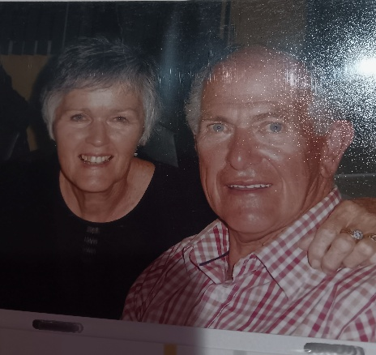


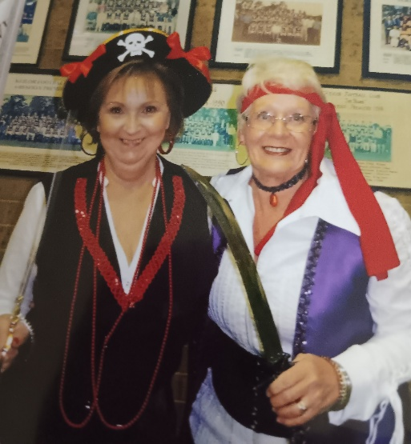

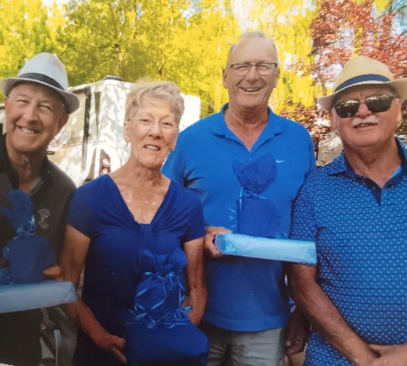
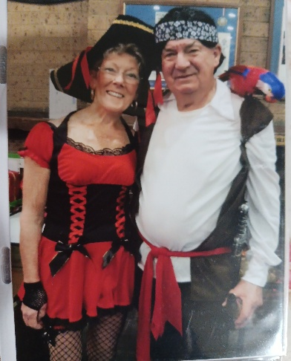

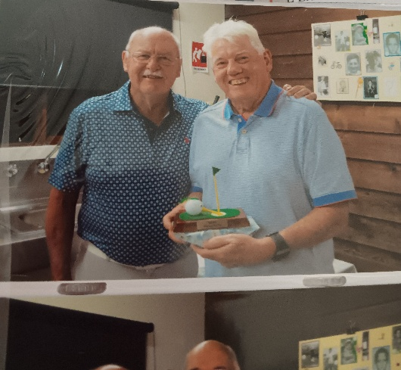

Fun days!

New Activity
“Yoga for All Abilities” was received very well. This yoga class is carried out on a floor mat, chair, walking frame or wheelchair. Yoga is not about being flexible or having a perfect pose, it’s about connecting with your body, mind, and breath. Whether you are new to exercise, or dealing with physical limitations yoga can accommodate your needs. Yoga is a practice accessible to everyone.
Thank you! to Glenys Adams who has taken on the convener’s role for this activity.
Golf
We have another most appreciated new convener, Mark Lipplegoes. Mark has taken on this role to ensure KLAC golf continues in the manner Graeme Smith had it operating.
Golf is a great activity; it helps in reducing stress (most of the time) because of the physical activity due to the pleasure of walking in an open and natural environment. Like all our activities, great opportunity to meet new people. Thank you, Mark. I know the KLAC golfers and the committee support you going forward.
KLAC Members Monthly Draw
The lucky winner
February – Bernie Katz Congratulations!
New Members

Welcome!
Rose Wells | Danielle May | Andrea Manley

First Two Dine Outs for 2026
Maria will have a list out in the club rooms. Remember you can bring a friend, however, after three events/activities they will need to join the club if they intend to continue joining an activity.

Venue | Date | Time
Deer Park Club | 20th February 2026 | 12.30pm
Keilor Hotel | 20th March 2026 | 12.30pm

Bus Trip – 5 Days
Trip to the beautiful high country staying in Bright.
Date: Leaving 25th May 2026 returning home 29th May 2026
Cost: $825 ($200 single supplement)
This trip is booked out; Dianne has a waiting list you are welcome to place your name on.

Theatre
Show | Payment Dates | Event Date | Theatre | Cost
Waitress | 30th March | 13th May 2026 1.00pm | Her Majesty’s | $70
Pretty Women | 23rd March | 22nd July 2026 1.00pm | The Regent | $90
A Beautiful Noise | 15th June | 19th August 2026 1.00 pm | The Princess | $90
Six The Musical | 29th June | 2nd September 2026 1.00pm | Comedy Theatre | $80
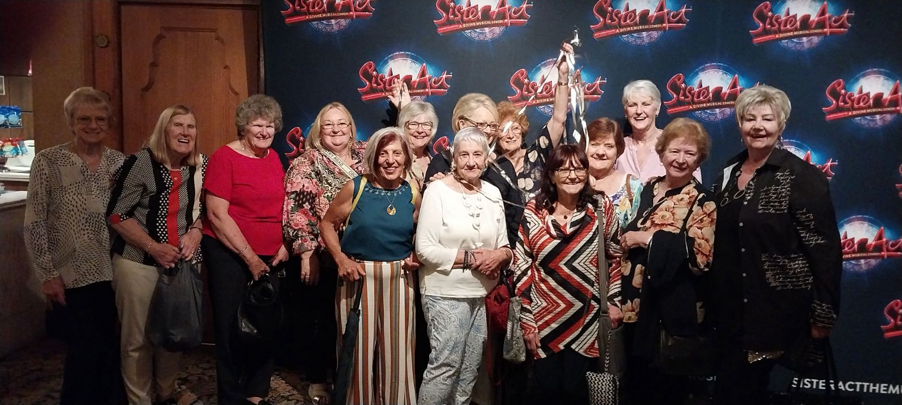
NB The theatre ticket prices are Pensioner / Concession Rates – payments must be paid by due dates

Bunnings Sausage Sizzle

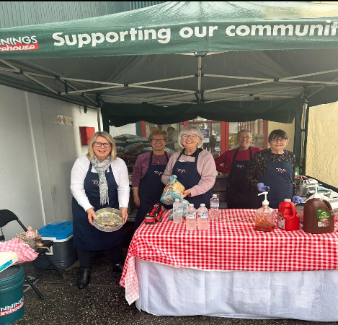
We’d like to sincerely thank Yasmin from McIntyre Lunch Box Catering for kindly providing the cut onions for our recent sausage sizzle. We truly value her company’s continued support of the community and look forward to trying more of their products at our upcoming club lunches. Visit her website at www.mcintyrelunchbox.com.au

We are ever grateful to the staff at Bunnings, Taylors Lakes for their
respect and unconditional support. thank you.

Monday 10.00 am- 2.00 pm
coffee/tea/chat
Register for outings/activities/special events
1st Monday of Month Chair Aerobics 12.00 pm/ Bingo 11.00am
2nd Monday Month Members Draw / Hip Hop 12.00
3rd Monday Month Trading Table/ Books / Raffles /Bingo / Hip Hop 12.00 pm
4th Monday Speaker (as advertised) / Hip Hop 12.00
MONDAY
Ukulele – TBA – Judy Waterhouse 0438 142 700
Hip Hop – 12.00 pm - 0414 757 632
TUESDAY
Golf – 9.30am for 10.00am start (Keilor Golf Course) Convener: Mark Lipplegoes 0415 356 259
Assistant Golf Convener: Graeme Smith 0423 154 428
Meditation in Motion - 10.00 am – 11.00 am Convener: Kerry Pollock 0409 792 654
Yoga for all abilities – 11.15am Convener: Glenys Adams. All abilities yoga can be mat on the floor, in a walking frame / wheelchair or on chair. Where you are most comfortable.
Latin Lovers Line Dancing – 12.30pm Convener: TBA
WEDNESDAY
Chorus Line – 10.00-11.00am – Convener: Vivian Scarr 0417 120 069
Walking Football- (Keilor Basketball Stadium) 1.00- 2.00pm Convener: TBA
THURSDAY
Thursday Tai Chi – 10.00 – 11.00 am Convener: Georgina Hall 0418 124 890
Bike Riding – 10.00am Convener: Judy Waterhouse 0438 142 700
Walking Basketball – (Keilor Basketball Stadium) 11.30 – 12.30
FRIDAY
Nordic Walking/Walking (Brimbank Park) 9.30-10.30am Convener: Jill Kriechbaum 0431 182 713
Social Coffee and Chat (Brimbank Park) 10.30 am meet the walkers at the end of their walk, they may inspire you.
SATURDAY
Early Bird Breakfast (Slices) 9.30am Convener: Kerrie Hallows 0415 133 554 (Last Saturday of month)

Contacts
Website Master – Trevor Withers -t.withers47@bigpond.com
Purchasing Officer – Georgina Hall - 0418 124 890
Bus Trips – Dianne Robinson – 0438 242 512
Live Theatre – Norma Cocks – 0407 097 216
Club Uniforms –Glenys Adams - 0414 757 632
Dine-outs – Maria Rizzas – 0407 865 075
Trading Table – Sandra Bennett – 0452 366 380
Debit Details For any Payments
Direct Debit: MUST include description
BSB No. 063 591
Account No. 10137201 Name: Keilor Life Activities Club Inc.
Cash payments
Payment table in KLAC Club Rooms
Payment Table closes at 11.30 am



