NEWSLETTER
January 2026

P.O Box 99 Keilor 3036 www.keilorlife.com
Visit our Club Rooms Keilor Sports Club!
Old Calder Highway, Keilor

August 2025
Club Rooms are Keilor Sports Club.
Old Calder Highway, Keilor
Club Patrons: Tony and Warwick Borello

President  Joan Ellis  Mob: 0408 362 697  president@keilorlife.com | Secretary  Glenys Adams -  Mob: 0414 757 632  admin@keilorlife.com | Web Master  Trevor Withers  t.withers47@bigpond.com  Carer  Judith Cave – Mob: 0408 301 057
Vice-President  Judith Cave  Mob:0408 301 057  info@keilorlife.com | Treasurer  Sue Lovell  Mob: 0402 056 070  Assistant Treasurer  Neil Webster  Neil13web@aol.com | Photographer  Di Robinson  Mob: 0438 242 512

Presidents Report January 2026
Happy New Year!
Let us continue as one big positive team into 2026. Thank you to the members who have given time during our break to assist at three “Sausages Sizzles”. It is amazing the revenue the good old Aussie snag brings into our club. We are celebrating a happy milestone in our club rooms that I would hope you will attend.
Monday 23rd February 2026 – KLAC’s 21st Birthday.
Doors will open 11.00 am – food, entertainment RSVP – list in clubrooms. You can book a table of ten. Price $25 - per head. Drinks at bar prices.
My best wishes for 2026
Keep well and smiling,
Joan

“The greatest gift you can give someone is your time because when you give your time, you are giving a portion of your life that you will never get back.”

Club Supporters
We gratefully acknowledge the ongoing support of:



Warwick Borello
Accountant Support

Check out how we looked 15 years ago
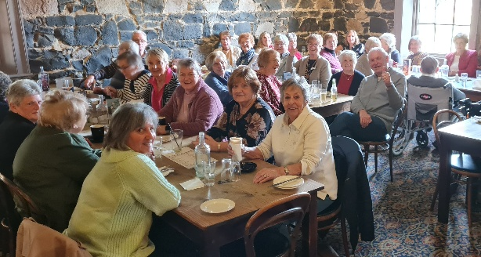



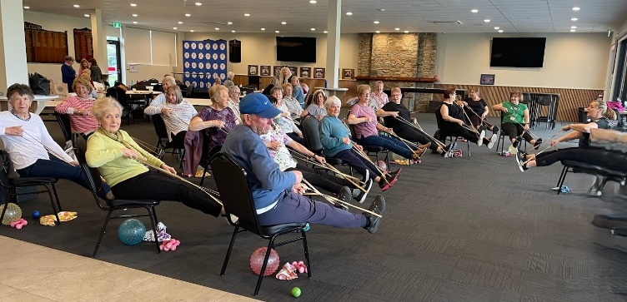

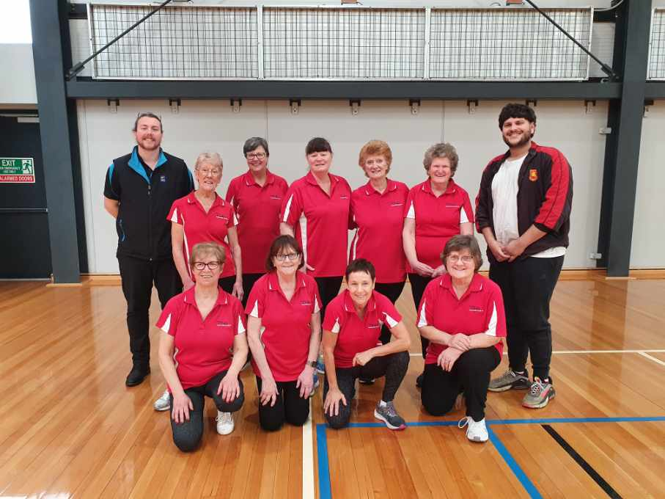
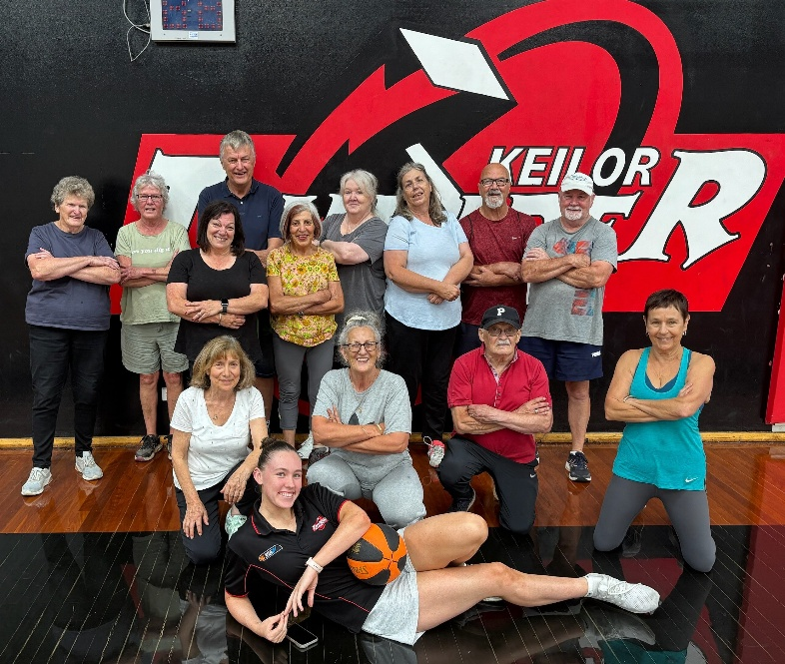


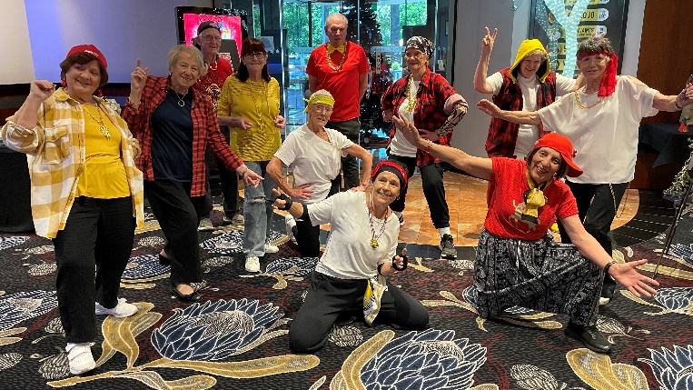

We do have lots of fun!
Sadly, 3rd January 2026 we lost a club member who was a true Christian in every sense of the word, Brian Cameron. Brian served on the KLAC steering committee and continued as a committee member. He transported many members (his harem) each week to morning melodies, and all the cream cake shops in the western suburbs, buying a special vehicle for the purpose. A beautiful person who will be sadly missed.
To Margaret and family, may you have happy memories of Brian, our deepest sympathy to you all.
Vale Brian Cameron

New Activity
Yoga – this activity to commence Tuesday 10th February 2026, 11.30 am.
KLAC Members Monthly Draw
The lucky winner
November – Wendy McKenzie Congratulations!
New Members –
Roula Rae  Welcome back.  Kate O'Callaghan | Paula Uren | Christine Grogan
First Two Dine Outs for 2026
Maria will have a list out in the club rooms. Remember you can bring a friend, however, after three events/activities they will need to join the club if they intend to continue joining an activity.

Venue | Date | Time
Deer Park Club | 20th February 2026 | 12.30pm
Keilor Hotel | 20th March 2026 | 12.30pm

Bus Trip – 5 Days
Trip to the beautiful high country staying in Bright.
Date: Leaving 25th May 2026 returning home 29th May 2026
Cost: $825 ($200 single supplement)
Dianne will have a list in the clubrooms (a lovely Mother’s Day Present)

Theatre
Show | Payment Dates | Event Date | Theatre | Cost
Waitress | 30th March | 13th May 2026 | Her Majesty’s | $70
Pretty Women | 23rd March | 22nd July 2026 | The Regent | $90
A Beautiful Noise | 15th June | 19th August 2026 | The Princess | $90
Six The Musical | 29th June | 2nd September 2026 | Comedy Theatre | $80
NB The theatre ticket prices are Pensioner / Concession Rates – payments must be paid by due dates

Monday 10.00 am- 2.00 pm
coffee/tea/chat
Register for outings/activities/special events
1st Monday of Month Chair Aerobics 12.00 pm/ Bingo 11.00am
2nd Monday Month Members Draw / Hip Hop 12.00
3rd Monday Month Trading Table/ Books / Raffles /Bingo / Hip Hop 12.00 pm
4th Monday Speaker (as advertised) / Hip Hop 12.00
MONDAY
Ukulele – TBA – Judy Waterhouse 0438 142 700
Hip Hop – 12.00 pm - 0414 757 632
TUESDAY
Golf – 9.30am for 10.00am start Convener: Graeme Smith 0423 154 428 (Keilor Golf Course)
Meditation in Motion - 10.00 am – 11.00 am Convener: Kerry Pollock 0409 792 654
Latin Lovers Line Dancing - 1.00 pm – 2.00pm Convener: TBA
Yoga - TBA
WEDNESDAY
Chorus Line – 10.00-11.00am – Convener: Vivian Scarr 0417 120 069
Walking Football- (Keilor Basketball Stadium) 1.00- 2.00pm Convener: TBA
THURSDAY
Thursday Tai Chi – 10.00 – 11.00 am Convener: Georgina Hall 0418 124 890
Bike Riding – 10.00am Convener: Judy Waterhouse 0438 142 700
Walking Basketball – (Keilor Basketball Stadium) 11.30 – 12.30
FRIDAY
Nordic Walking/Walking (Brimbank Park) 9.30-10.30am Convener: Jill Kriechbaum 0431 182 713
Social Coffee and Chat (Brimbank Park) 10.30 am meet the walkers at the end of their walk, they may inspire you.
SATURDAY
Early Bird Breakfast (Slices) 9.30am Convener: Kerrie Hallows 0415 133 554 (Last Saturday of month)

Contacts
Website Master – Trevor Withers -t.withers47@bigpond.com
Purchasing Officer – Georgina Hall - 0418 124 890
Bus Trips – Dianne Robinson – 0438 242 512
Live Theatre – Norma Cocks – 0407 097 216
Club Uniforms –Glenys Adams - 0414 757 632
Dine-outs – Maria Rizzas – 0407 865 075
Trading Table – Sandra Bennett – 0452 366 380
Debit Details For any Payments
Direct Debit: MUST include description
BSB No. 063 591
Account No. 10137201 Name: Keilor Life Activities Club Inc.
Cash payments
Payment table in KLAC Club Rooms
Payment Table closes at 11.30 am

