NEWSLETTER
October 2025

P.O Box 99 Keilor 3036 www.keilorlife.com
Visit our Club Rooms Keilor Sports Club!
Old Calder Highway, Keilor

August 2025
Club Rooms are Keilor Sports Club.
Old Calder Highway, Keilor
Club Patrons: Tony and Warwick Borello

President  Joan Ellis  Mob: 0408 362 697  president@keilorlife.com | Secretary  Glenys Adams -  Mob: 0414 757 632  admin@keilorlife.com | Web Master  Trevor Withers  t.withers47@bigpond.com  Carer  Judith Cave – Mob: 0408 301 057
Vice-President  Judith Cave  Mob:0408 301 057  info@keilorlife.com | Treasurer  Sue Lovell  Mob: 0402 056 070  Assistant Treasurer  Neil Webster  Neil13web@aol.com | Photographer  Di Robinson  Mob: 0438 242 512

Presidents Report October2025

Official Opening of the Keilor Sports Club
All members are invited to attend the official opening of the Keilor Sports Club.
- Friday 24th October 2025
- 10.00 am - Official speeches
Come along and celebrate with the people who made this community “happy space”.
- Monday 20th October 2025
- 10.30 am – doors open
- 11.30 - official welcome and special entertainment

All our conveners will have their activities on displayed. Please make the effort to support these wonderful members who give their time unconditionally.
On behalf of the committee, we do hope to catch up with you on the day.
Keep well,
Joan
“To succeed in life, you need three things: a wishbone, a backbone, and a funny bone.”

Club Supporters
We gratefully acknowledge the ongoing support of:



Warwick Borello
Accountant Support

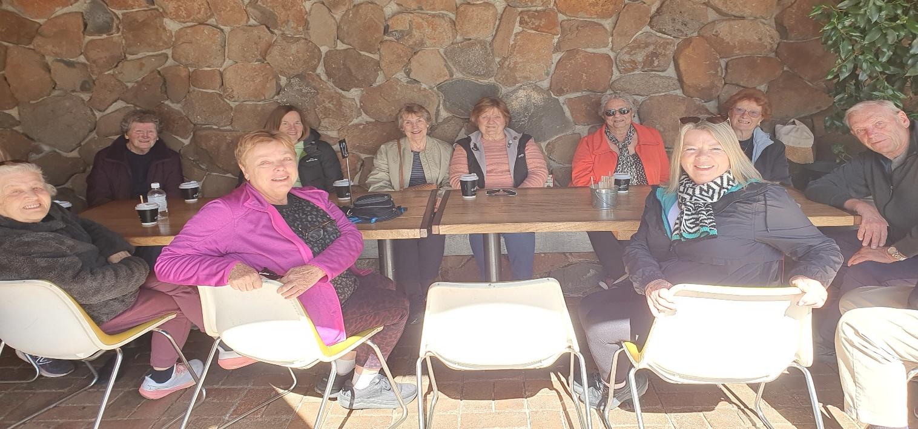
Nordic Walkers! not sure about this group. When asked for a photo of Fridays Nordic Walking, this is the photo. Looks like an invigorating walk. They are a welcoming, fun group, obviously enjoy a social coffee and while walking through Brimbank Park, they solve the problems of the world. If you haven’t yet, give Nordic Walking a try.

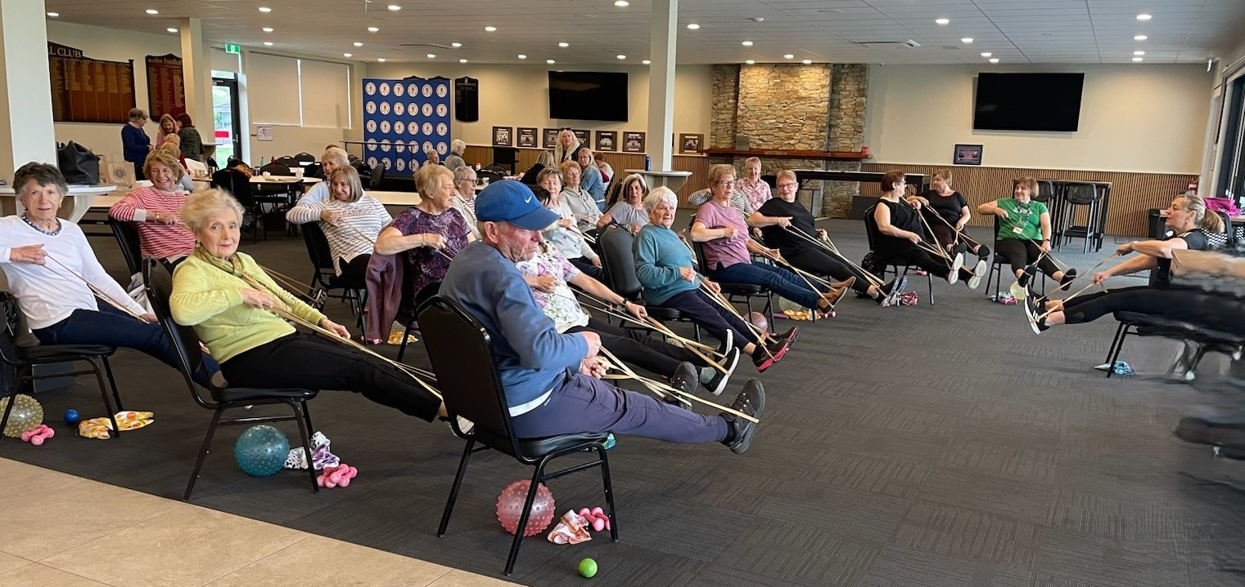
Chair Aerobics with the lovely fitness instructor - Lucy – this class is the first Monday of every month.

Helpful Aids:
Geoff Thompson has 2 x walkers and a wheelchair available for loan. Mobile : Geoff. 0418 341 843

KLAC Members Monthly Draw
The lucky winner
September – Padma Ketty
Congratulations!
New Members – we welcome you and hope to meet and greet with you all at the club rooms 20th October 2025. All our club activities will be on display. You are also welcome to bring a friend.
- Carmel Barbaro | - Jennifer Castellas |  |  | - Jenny Drago
- Helen Karalis | - Thelma Johston
- Ninette Hermansson |  | - Tracy Towner

Dine Outs – The October lunch is the same day as the official opening of the Sports Club / our club rooms.
The official opening will commence 10.00 am, finish 10.30 am. Come along to this historical event and then go and celebrate ay Cross Keys Hotel.

Venue | Date | Time
Cross Keys Hotel | Friday 24th October | 12.30pm
St Albans SPORTS' Centre | Friday 21st November | 12.30pm

Bus Trip –
This trip has proved very popular, well-done Diane.

Place | Date | Time | Program
Daylesford | Friday 14 November 2025 | 8.30am - Depart Keilor Hotel | Morning Tea at The Covent  Devonshire Tea  Talk on the history, then free time to wander through.
 |  | 5pm - Arrive Home | Lunch at Daylesford Bowling club.  Talk on Willow cricket, this is where they make cricket bats
Theatre
Payments and Confirmations MUST be by 10th November 2025
Show | Payment Dates | Event Date | Theatre | Cost
MJ The Musical | 10/11/25 | 14/1/2026 | Her Majesty’s | $110
CATS | 17/11/2025 | 4/2/2026 | Hamer Hall | $76
ANASTASIA | 17/11/ 2025 | 11/2/2026 | Regent | $70

Monday 10.00 am- 2.00 pm
coffee/tea/chat
Register for outings/activities/special events
1st Monday of Month Chair Aerobics 12.00 pm/ Bingo 11.00am
2nd Monday Month Members Draw / Hip Hop 12.00
3rd Monday Month Trading Table/ Books / Raffles /Bingo / Hip Hop 12.00 pm
4th Monday Speaker (as advertised) / Hip Hop
MONDAY
Ukulele – 10.00-11.00am – Judy Waterhouse 0438 142 700
Hip Hop – 12.00 pm - 0414 757 632
TUESDAY
Golf – 9.30am for 10.00am start Convener: Graeme Smith 0423 154 428 (Keilor Golf Course)
Meditation in Motion - 10.00 am – 11.00 am Convener: Kerry Pollock 0409 792 654
Latin Lovers Line Dancing - 1.00 pm – 2.00pm Convener: TBA
WEDNESDAY
Chorus Line – 10.00-11.00am – Convener: Vivian Scarr 0417 120 069
Walking Football- (Keilor Basketball Stadium) 1.00- 2.00pm Convener: TBA
THURSDAY
Thursday Tai Chi – 10.00 – 11.00 am Convener: Georgina Hall 0418 124 890
Bike Riding – 10.00am Convener: Judy Waterhouse 0438 142 700
Walking Basketball – (Keilor Basketball Stadium) 11.30 – 12.30
FRIDAY
Nordic Walking/Walking (Brimbank Park) 9.30-10.30am Convener: Jill Kriechbaum 0431 182 713
Social Coffee and Chat (Brimbank Park) 10.30 am meet the walkers at the end of their walk, they may inspire you.
SATURDAY
Early Bird Breakfast (Slices) 9.30am Convener: Kerrie Hallows 0415 133 554 (Last Saturday of month)

Contacts
Website Master – Trevor Withers -t.withers47@bigpond.com
Bus Trips – Dianne Robinson – 0438 242 512
Live Theatre – Norma Cocks – 0407 097 216
Club Uniforms –Glenys Adams - 0414 757 632
Dine-outs – Maria Rizzas – 0407 865 075
Trading Table – Sandra Bennett – 0452 366 380
Hospitality – Joanna Sergiou – 0409 182 025
Debit Details For any Payments
Cash payments desk in KLAC Club Rooms
Direct Debit: MUST include description
BSB No. 063 591
Account No. 10137201 Name: Keilor Life Activities Club Inc.

