NEWSLETTER
P.O Box 99 Keilor 3036
www.keilorlife.com

July 2025
Club Rooms are Keilor Sports Club.
Old Calder Highway, Keilor
Club Patrons: Tony and Warwick Borello

President  Joan Ellis  Mob: 0408 362 697  president@keilorlife.com | Secretary  Glenys Adams -  Mob: 0414 757 632  admin@keilorlife.com | Web Master  Trevor Withers  t.withers47@bigpond.com  Carer  Judith Cave – Mob: 0408 301 057
Vice-President  Judith Cave  Mob:0408 301 057  info@keilorlife.com | Treasurer  Sue Lovell – 0402 056 070  accounts@keilorlife.com  Assistant Treasurer  Neil Webster  Neil13web@aol.com | Photographer  Dianne Robinson - 0438 242 512  Membership Secretary.  info@keilorlife.com (Position Vacant)

Presidents Report July 2025
When you read this newsletter, we will be back in our club rooms. There are many people to thank. The members for their support and patience and the many new members who have come on board knowing times and places will change. Most importantly the Sports Club Committee, you can only guess the time they have given unconditionally. Thank you to Hayden Kelly and his team.
The following is an invitation from Hayden and his team.
The Keilor Sports Clubrooms are completed and will be open from Saturday 5 July. To complete the build in 9 months and on budget is a great effort from the core group responsible for the building phase.
The Sports Club is keen to thank all those from the Keilor sports and wider community who have contributed to a magnificent facility which will serve the community for many years to come. To that end a community open night will be held on Friday 18 July commencing at 5pm. This event is open to all to come along, view the rooms, have a drink, something to eat and enjoy each other’s company.
Keep warm and well
Joan
“The only place where success comes before work is in the dictionary.”
Club Supporters

We gratefully acknowledge the ongoing support of: -
Warwick Borello - Accountant Support
Office of Natalie Hutchins MP – Newsletter Printing

KLAC Members Monthly Draw
No draw this month. Sorry, we were so carried away with new rooms and all that was happening, we forgot. This month a Jackpot two months prise.
New Members
Welcome to our Newest Member…….. Suzanne Mitchell

A Big Thank You.
Keilor Life Activities Club, has been blessed over the past 9 months during the rebuild of the Sports Club to be able to have the weekly use of wonderful facilities, provided to us by varied local community/church groups.
We are most grateful and thankful to the following venues:
Keilor Bowling Club *Monday, Drop-in Day.
Keilor Tennis Club *Monday, Ukelele
St Stephens Uniting Church, Keilor *Tuesday, Tai Chi
Avonde Calisthenics Tullamarine *Wednesday, Chorus Line
Arundel Farm Keilor *Thursday, Tai Chi
And, to all our wonderful members a big thank you too, for your patience and loyalty throughout the disruptions. Back to the Future….


t
Thank you to these ladies who gave up their time and spent it gossiping…… It was a very pleasant afternoon cleaning silver that is on display in our club rooms.
Well done! Great display.

Theatre
Watch this space
Norma has new shows booked, keep checking the activity boards.
ANNIE - Wednesday 13th August 2025
Princess Theatre
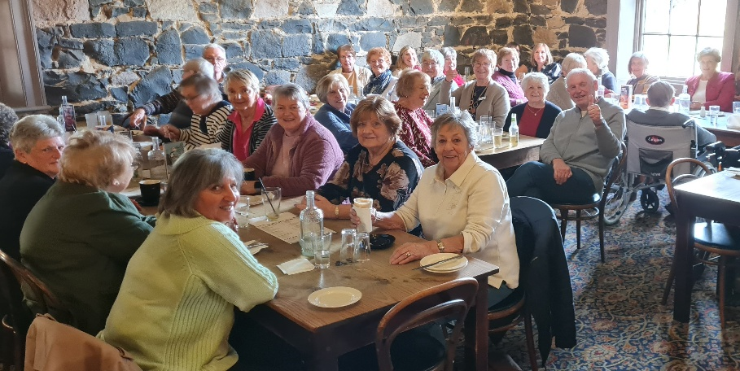
Happy dine-out members at the Keilor Hotel in June. If you are into food this is a happy group to join.

Dine Out for July
Venue: Deer Park Club, 780 Ballarat Road, Deer Park
Date: Friday 18th July Time: 12.30pm
Convener: Maria 0407 865 07

New Activities
Both these activities are on Tuesday. Try them both out, or at least one of them.
- Qigong a ‘New Type’ of Tuesday Activity
Time: 10.00am Venue: KLAC Club rooms Cost: $5.00
Activity description - Meditation in Motion
This activity involves flowing movements with breathing in synchronicity, to maximise mindfulness, a traditional mental and physical health exercise that sees the body holistically. It will cater for all abilities as the excise can also, be done sitting. Newcomers most welcome.
Teacher: Yong Kuo Convener: Kerry 0409 792 654
- Line Dancing
Time: 1.00pm Venue: KLAC Club rooms Cost: $5.00
Activity description - It is a fantastic form of cardiovascular exercise, as it gets your heart rate up and improves your cardiovascular fitness.
Line dancing can help to improve your balance and coordination, as the movements require you to stay in sync with the music and the other dancers.

Teacher: Maria Vallesta Convener: TBA
All our activities are social activities that promote interaction and connection with others, providing a sense of community and support.
All members are welcome at all activities, you can bring along a friend / mate who is not a club member; after attending a third activity/event they must join our club to continue attending.

A bitter/ sweet final day for this Tai Chi group who having spent the last nine months being spoilt by the wonderful staff at Arundel farm, while looking forward to our new club rooms, they were very grateful to the staff and would miss their company each week.
It was our final day at Arundel Estate with our tai chi group. We presented them with a beautiful hamper and expressed our gratitude for their warm hospitality during our visit. Afterwards, we enjoyed a delightful
lunch. If you have the chance, do stop by and sample their menu!

Keilor Life Activities Club Inc.
Monday 10.00 am- 2.00 pm
Activities include coffee/tea/chat
Register for outings/activities/special events
1st Monday of Month Committee Meeting /Chair Aerobics 12.00 / Bingo 11.00am
2nd Monday Month Members Draw / Hip Hop 12.00
3rd Monday Month Trading / Books / Raffles /Bingo / Hip Hop
4th Monday Speaker (as advertised) / Hip Hop
OUR CONVENERS
MONDAY
Ukulele – 10.00-11.00am – Judy Waterhouse 0438 142 700
Hip Hop – 11.30 – 12.30 - 0414 757 632
TUESDAY
Golf – 9.30am for 10.00am start Convener: Graeme Smith 0423 154 428 (Keilor Golf Course)
Meditation in Motion - 10.00 am – 11.00 am Convener: Kerry Pollock 0409 792 654
Line dancing - 1.00 pm – 2.00pm Convener: TBA
WEDNESDAY
Chorus Line – 10.00-11.00am – Convener: Vivian Scarr 0417 120 069
Walking Football- (Keilor Basketball Stadium) 1.00- 2.00pm Convener: TBA
THURSDAY
Thursday Tai Chi – 10.00 – 11.00 am Convener: Georgina Hall 0418 124 890
Bike Riding – 10.00am Convener: Judy Waterhouse 0438 142 700
Walking Basketball – (Keilor Basketball Stadium) 11.30 – 12.30
FRIDAY
Nordic Walking/Walking (Brimbank Park) 9.30-10.30am Convener: Jill Kriechbaum 0431 182 713
Social Coffee and Chat (Brimbank Park) 10.30 am meet the walkers at the end of their walk, they may inspire you.
SATURDAY
Early Bird Breakfast (Splices) 9.00am Convener: Kerrie Hallows 0415 133 554 (Last Saturday of month)
Chair Aerobics - 1st Monday of the month 12.00 pm.
Bingo – 1st Monday and 3rd Monday of the month 11.00 am
Hip Hop – Every Monday 11.30 (Except 1st Monday when there is Chair Aerobics)
Website Master – Trevor Withers -t.withers47@bigpond.com
Bus Trips – Dianne Robinson – 0438 242 512
Live Theatre – Norma Cocks – 0407 097 216
Club Uniforms –Glenys Adams - 0414 757 632
Dine-outs – Maria Rizzas – 0407 865 075
Trading Table – Sandra Bennett – 0452 366 380
Hospitality – Joanna Sergiou – 0409 182 025
Debit Details For any Payments: Cash payments desk in KLAC Club Rooms
Direct Debit: MUST include description
BSB No. 063 591
Account No. 10137201
Account Name. Keilor Life Activities Club Inc.

.

