NEWSLETTER
September 2025

P.O Box 99 Keilor 3036 www.keilorlife.com
Visit our Club Rooms Keilor Sports Club!
Old Calder Highway, Keilor

August 2025
Club Rooms are Keilor Sports Club.
Old Calder Highway, Keilor
Club Patrons: Tony and Warwick Borello

President  Joan Ellis  Mob: 0408 362 697  president@keilorlife.com | Secretary  Glenys Adams -  Mob: 0414 757 632  admin@keilorlife.com | Web Master  Trevor Withers  t.withers47@bigpond.com  Carer  Judith Cave – Mob: 0408 301 057
Vice-President  Judith Cave  Mob:0408 301 057  info@keilorlife.com | Treasurer  Sue Lovell  Mob: 0402 056 070  Assistant Treasurer  Neil Webster  Neil13web@aol.com | Photographer  Di Robinson  Mob: 0438 242 512  Membership Secretary.  Teddie Hughes  edwinaehughes@hotmail.com

Presidents Report September 2025
Thank you, to all who attended the AGM and the two KLAC members who have joined our governance team. Teddie Hughes, our new Membership Secretary. Barbara Griggs, who has joined as a committee member. We look forward to your new ideas and helping hands.
Welcome back, to Sandra Bennett and her team. The trading table last month was a great success. The revenue for KLAC is generated from memberships, the trading table, raffles, bingo and sausage sizzles. The support from teams working these areas and all club members is excellent, all is given unconditionally, thank you.
The date for the KLAC Expo is Monday the 20th October 2025. This is a day to show case our club to your friends and family. To encourage, lonely people, who need to enhance their lives by reaching out and feeling the friendships that are on offer, making them want to get up each morning. If nothing else, bring them along for a cuppa, sandwich and a chat. Share the love and friendship.

Enjoy the spring weather,
Joan
“We all have two lives.
The second one starts when we realize we only have one.”

Club Supporters
We gratefully acknowledge the ongoing support of:



Warwick Borello
Accountant Support

KLAC Committee 2025/2026

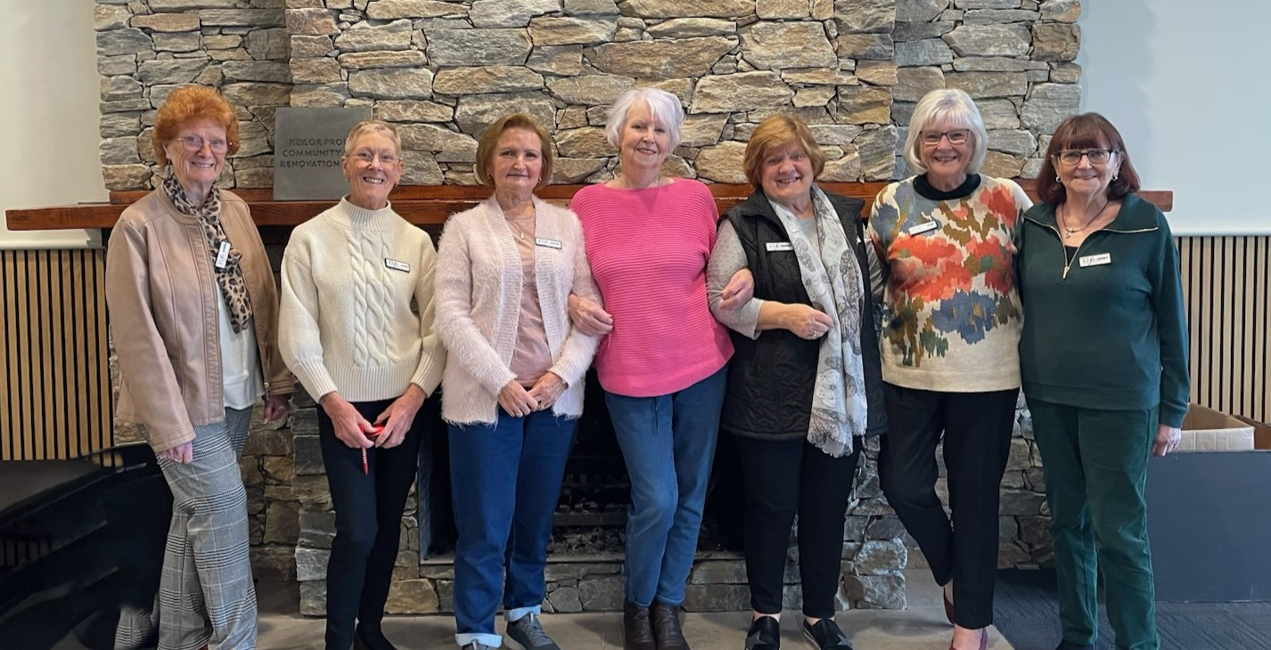
From the left: Norma Cocks, Joan Ellis, Barbara Griggs, Glenys Adams, Dianne Robinson, Sue Lovell, Jenny Craig
Absent: Judy Cave, Teddie Hughes, Neil Webster

KLAC Members Monthly Draw
The lucky winner
August – Faye Absolom
Congratulations!
New Members – we welcome you and hope you add new friends and activities to your life.
- Jackie Thompson | - Vanessa Cocks |  |  | - Carla George
- Pamela Milligan | - Maria Steanic
- Joy Schornikow |  | - Rita La Ganao

Speaker:
Monday 29th September 2025. 10.30 am
“A Day in the life of a Retrieval Doctor in Rural & Remote Australia”

Dr Bill Nimo will share how he got into this field, the training involved, and the importance of being an educator and mentor. He will touch on his special interest in snakes and spider bites. There will be time at the end for questions and coffee and cakes.

Dine Outs – the dine outs are for lunch. Maria is mindful of travelling and information given to her by members. Her caring way and thoughtfulness give our members a very enjoyable lunch date.

Venue | Date | Time
Cross Keys Hotel | Friday 24th October | 12.30pm
St Albans SPORTS' Centre | Friday 21st November | 12.30pm

Bus Trip – Yep! Di’s at it again and it looks like a great day.

NO bookings will be taken until Monday 22nd September. Please don’t contact Di re bookings before this date.
Place | Date | Time | Program
Daylesford | Friday 14 November 2025 | 8.30am - Depart Keilor Hotel | Morning Tea at The Covent  Devonshire Tea  Talk on the history, then free time to wander through.
 |  | 5pm - Arrive Home | Lunch at Daylesford Bowling club.  Talk on Willow cricket, this is where they make cricket bats
Theatre
Contact Norma, if you have any queries or issues, don’t leave it until the last minute.
Show | Payment Dates | Event Date | Theatre | Cost
MJ The Musical | 10/11/25 | 14/1/2026 | Her Majesty’s | $110
CATS | 17/11/2025 | 11/2/26 | Hamer Hall | $75.50
ANASTASIA | 17/11/ 2025 | 11/2/26 | Regent | $70.00

Monday 10.00 am- 2.00 pm
coffee/tea/chat
Register for outings/activities/special events
1st Monday of Month Chair Aerobics 12.00 / Bingo 11.00am
2nd Monday Month Members Draw / Hip Hop 12.00
3rd Monday Month Trading Table/ Books / Raffles /Bingo / Hip Hop
4th Monday Speaker (as advertised) / Hip Hop
MONDAY
Ukulele – 10.00-11.00am – Judy Waterhouse 0438 142 700
Hip Hop – 12.00 pm - 0414 757 632
TUESDAY
Golf – 9.30am for 10.00am start Convener: Graeme Smith 0423 154 428 (Keilor Golf Course)
Meditation in Motion - 10.00 am – 11.00 am Convener: Kerry Pollock 0409 792 654
Latin Lovers Line Dancing - 1.00 pm – 2.00pm Convener: TBA
WEDNESDAY
Chorus Line – 10.00-11.00am – Convener: Vivian Scarr 0417 120 069
Walking Football- (Keilor Basketball Stadium) 1.00- 2.00pm Convener: TBA
THURSDAY
Thursday Tai Chi – 10.00 – 11.00 am Convener: Georgina Hall 0418 124 890
Bike Riding – 10.00am Convener: Judy Waterhouse 0438 142 700
Walking Basketball – (Keilor Basketball Stadium) 11.30 – 12.30
FRIDAY
Nordic Walking/Walking (Brimbank Park) 9.30-10.30am Convener: Jill Kriechbaum 0431 182 713
Social Coffee and Chat (Brimbank Park) 10.30 am meet the walkers at the end of their walk, they may inspire you.
SATURDAY
Early Bird Breakfast (Slices) 9.30am Convener: Kerrie Hallows 0415 133 554 (Last Saturday of month)



Contacts
Website Master – Trevor Withers -t.withers47@bigpond.com
Bus Trips – Dianne Robinson – 0438 242 512
Live Theatre – Norma Cocks – 0407 097 216
Club Uniforms –Glenys Adams - 0414 757 632
Dine-outs – Maria Rizzas – 0407 865 075
Trading Table – Sandra Bennett – 0452 366 380
Hospitality – Joanna Sergiou – 0409 182 025
Debit Details For any Payments
Cash payments desk in KLAC Club Rooms
Direct Debit: MUST include description
BSB No. 063 591
Account No. 10137201 Name: Keilor Life Activities Club Inc.

