 NEWSLETTER

# **March 2025**

Club Rooms are Keilor Sports Club.

Old Calder Highway, Keilor

Club Patrons: Tony and Warwick Borello

**33**

PO Box 99, Keilor

www.keilorlife.com

|  |  |  |
| --- | --- | --- |
| *President:* *Joan Ellis*  *Mob: 0408 362 697*  *Email: Jel48981@bigpond.net.au* | ***Secretary*** */* ***Membership******Secretary.*** *Glenys Adams - 9077 0713* Mob: 0414 757 632  Email: glenysa@optusnet.com.au | **Web *Master***:  Trevor Withers - [t.withers47@bigpond.com](mailto:t.withers47@bigpond.com)  **Carer**: Judith Cave - 0408 301 057 |
| *Vice-President:**Judith Cave 9336 1133* *Mob:0408 301 057*  [*rexjude@hotmail.com*](mailto:rexjude@hotmail.com) | *Treasurer:* *Sue Lovell – 0402 056 070*  *lovellsue@hotmail.com*  ***Ass. Treasure****r Neil Webster*  *Neil13web@aol.com* | *Photographer*:Dianne Robinson - 0438 242 512 |

Presidents Report March 2025

24th February 2025 KLAC celebrated twenty years since inauguration. Our birthday party was celebrated at the Taylors Lakes Hotel. Members from the steering committee (21 years ago) other members in the room were foundation members paying the membership fee on the 21st February 2005. Our membership was and remains open to men and women in the over 50’s age group whether retired, nearing retirement or still in the workforce. Its aim is to assist men and women in that age group to cope with life changing events such as retirement, and to develop and maintain an active and enjoyable lifestyle.

The question asked back then **“Why join a Life Activities Club?”**

* They provide you with lots of options to make new friends and acquaintances.
* They provide the opportunity for you to keep physically and mentally alert, and to develop and maintain an active and enjoyable lifestyle.
* We are welcoming and operate in a friendly non-pressuring way.
* We offer a range of sporting, leisure, personal development and social activities to suit most tastes.
* Give you access to a range of benefits.

I believe all the above can be said of KLAC today, twenty years later. This is a great effort, thank you to all concerned.

Enjoy the Autumn weather.

Keep well.

*Joan*

***Some people, no matter how old they get, never lose their beauty- they simply move it from their faces into their hearts.***

**Club Supporters**

We gratefully acknowledge the ongoing support of: -

Warwick Borello - Accountant Support

Office of Natalie Hutchins MP – Newsletter Printing

KLAC members share the club’s 20th Birthday.

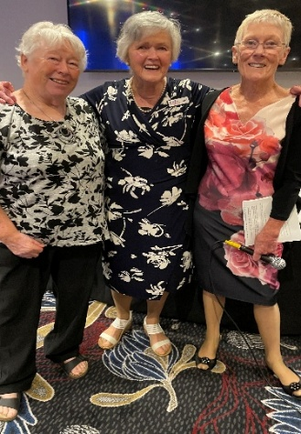On Monday 24th February 2025 many members shared a lunch to celebrate twenty years of the Keilor Life Activities Club. In the room we had Joy Tyrrell - First President, Judy Waterhouse -Second President, Joan Ellis -Third President, Ray Tyrrell - First Membership Secretary, Margaret Cameron - Committee Member. Barbara Robertson a Golden Member, and Brian Cameron were absent on the day. All these members worked on the Steering Committee that formed a strong foundation upon which our club has prospered. Joy read from the speech she made the day we inaugurated. The words Joy wrote twenty years ago for the aspirations of our club came to fruition, and for that we must thank you, our MEMBERS. You are the heart and soul of the club.

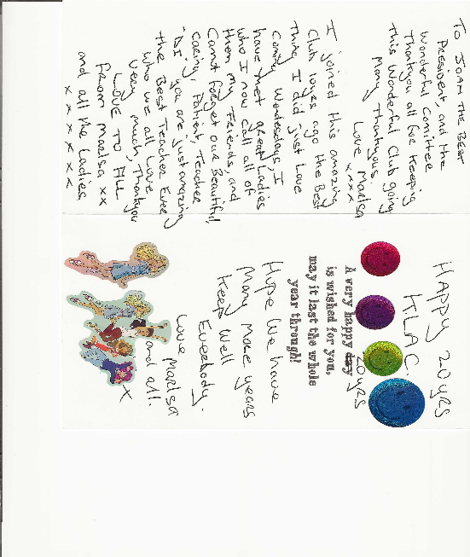Thank you to all the members who were able to celebrate the KLAC milestone. Was a great day**.**

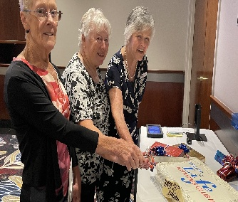

Cards like this make it all worthwhile,

thank you, Marlene X.

**New Members**

*Allan Cullington, Trish Riley, Wendy McKenzie, Genevieve Albanis*

Welcome to our new members. We hope you make new friends and go outside your circle and try a new activity. It maybe reading a book. We have many books at the club.

**Carers Report**

To John Newsome, Liz Thompson, Carmel Kane and all our members who are doing it tuff, we are sending you a BIG hug. We are here for you, please “reach out” to us if we can assist in anyway**.**

**Speaker**

Come along, bring a friend, and have a coffee while you listen to some much-needed information Monday 24th March 2025

2.00 – 3.00 pm

**Situations vacant** – looking for any members/friends, male or female who would like to help in the beer shed on home match days at Keilor.

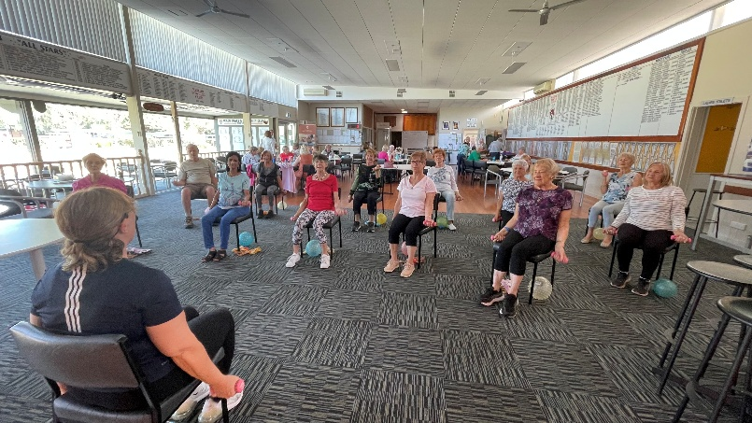 **Chair Aerobics**

Our lovely instructor “Lucy” faithfully

arrives on the first Monday of the month1.00pm, the enjoyment of the enthusiast members.

Thank you, Lucy.

**Bus Trip**

Friday 9th May 2025 – Creswick Woollen Mills

Departs: 8.30 am

Morning Tea: Woollen Mills

Lunch: Farmers Arms Hotel

Cost: $70

***Theatre***

 Norma has new theatre show lists out. Keep checking activity boards.

BEETLE JUICE MUSICAL - Wednesday 2nd July 2025 1.00pm

Regent Theatre

$90 per ticket. Must be confirmed and paid by 28th April

ANNIE - Wednesday 13th August 2025

Princess Theatre

$70 per ticket. Must be confirmed and paid – Monday 2nd June

On the drawing board. (interest from members)

Card games e.g. 500 / euchre

Line dancing

Choir

Water Aerobics

More Trivia Days / Nights

We are open to suggestions

**Keilor Life Activities Club Inc.**

**Monday 12.30 pm- 3.00pm**

**Activities include coffee/tea/chat**

**Register for outings/activities/special events**

1st Monday of Month Committee Meeting /Chair Aerobics 1.00pm / Bingo 2.00 pm

2nd Monday Month Hip Hop / Members Draw

3rd Monday Month Trading / Books / Raffles /Bingo / Hip Hop

4th Monday Speaker / Hip Hop

|  |
| --- |
| **OUR CONVENERS** |
| **MONDAY** |
| ***Ukulele*** – 10.00-11.00am – Judy Waterhouse 0438 142 700 |
|  |
| **TUESDAY** |
|  |
| ***Golf*** – 9.30am for 10.00am start (Keilor Public Golf Course) Convener: TBA |
|  |
| **WEDNESDAY** |
| ***Chorus Line*** – 10.00-11.00am – Vivian Scarr 0417 120 069 |
| ***Walking Football*-** (Keilor Basketball Stadium) 1.00- 2.00pm Convener: TBA |
|  |
| **THURSDAY** |
| ***Thursday Tai Chi*** – 10.00 – 11.00 am - Georgina Hall 0418 124 890 |
| ***Bike Riding*** *– 10.00am* - Judy Waterhouse 0438 142 700 |
| ***Walking Basketball –*** (Keilor Basketball Stadium) 11.30 – 12.30 |
| **FRIDAY** |
| ***Nordic Walking/Walking*** (Brimbank Park) 9.30-10.30am Jill Kriechbaum 0431 182 713 |
| ***Social Coffee and Chat*** (Brimbank Park) 10.30 am meet the walkers at the end of their walk, they may inspire you. |
|  |
| **SATURDAY** |
| ***Early Bird Breakfast*** (Café Brimbank Park) 9.00am Kerrie Hallows 0415 133 554 (Last |
| Saturday of month) |

**Chair Aerobics** - 1st Monday of the month 1.00 pm.

**Bingo** – 1st Monday and 3rd Monday of the month 2.00pm

**Hip Hop** – Every Monday 12.30 (Except 1st Monday when there is Chair Aerobics)

**Website Master** – Trevor Withers -t.withers47@bigpond.com

**Bus Trips** – Dianne Robinson – 0438 242 512

**Live Theatre** – Norma Cocks – 0407 097 216

**Club Uniforms** –Glenys Adams - 0414 757 632

**Dine-outs** – Maria Rizzas – 0407 865 075

**Trading Table –** Sandra Bennett – 0452 366 380

**Hospitality –** Joanna Sergiou – 0409 182 025

***Debit Details For any Payments:* Cash payments desk in KLAC Club Rooms**

* **Direct Debit: *MUST include description***

**BSB No. 063 591**

**Account No. 10137201**

**Account Name. Keilor Life Activities Club Inc.**