 NEWSLETTER

# **February 2025**

Club Rooms are Keilor Sports Club.

Old Calder Highway, Keilor

Club Patrons: Tony and Warwick Borello

**33**

PO Box 99, Keilor

www.keilorlife.com

|  |  |  |
| --- | --- | --- |
| *President:* *Joan Ellis*  *Mob: 0408 362 697*  *Email: Jel48981@bigpond.net.au* | ***Membership******Secretary.*** *Glenys Adams - 9077 0713* Mob: 0414 757 632  Email: glenysa@optusnet.com.au | **Web *Master***:  Trevor Withers - [t.withers47@bigpond.com](mailto:t.withers47@bigpond.com)  **Carer**: Judith Cave - 0408 301 057 |
| *Vice-President:**Judith Cave 9336 1133* *Mob:0408 301 057*  [*rexjude@hotmail.com*](mailto:rexjude@hotmail.com) | *Treasurer:* *Sue Lovell – 0402 056 070*  *lovellsue@hotmail.com*  ***Ass. Treasure****r Neil Webster*  *Neil13web@aol.com* | *Photographer*:Dianne Robinson - 0438 242 512 |

**Happy New Year! 🍾 🥂 2025.**

Welcome this year with open arms. Let’s make it a good one. What we know without doubt is we cannot change 2024, or anything, that happened yesterday. We are lucky to have wonderful experiences from the last 50, 60,70,80,90, years (beautiful memories) to pass on to family and friends. 2025 is the year to make many more……………...We can look forward to our new club rooms. The building is looking great. A magnificent effort by the building team,

**10th February 2025 -** Our club KLAC to resume. We will continue our activities at the venues we were attending prior the Christmas break. Please check with the activity convener as not all activities are commencing the first week in February.

**24th February 2025 -KLAC’s** 20th birthday. There will be a list available on Monday at the bowling club. Excellent venue, however, I was disappointed in the food and presentation at our Christmas function. This has been addressed, and I am assured, the menu will be to all attendee’s delight. Hella, you can leave your machete home, I have asked for the vegies to be cooked a bit longer.

**New Year Resolution for 2025**

Attend new activities, even, even as a spectator giving support to the participants, meet new people(friends) share a coffee and interact with new people in your life.

As I have mentioned many times, I encourage you all, try a physical activity. Keeps old Arthur away (arthritis) This may not be correct advice.

A rabbit runs and hops and only lives 10 years, while a tortoise doesn't run and does mostly nothing, yet it lives for 150 years, and I am encouraging you to exercise? Perhaps not such a good idea!!!

This newsletter, as always, will be online. Hard copy is available in the club rooms or contact us and we will arrange a pickup point for you. This is apart from Helen and Len Pritchard, who reside in Queensland and continue their membership. Our committee is aware the post costs are increasing; we are looking for alternative arrangements. We may have to go back to smoke signals.

We look forward to greeting you and your friends soon.

Keep well.

Joan

***“People often say that motivation doesn’t last. Well, neither does bathing. That’s why we recommend it daily.”***

**Club Supporters**

We gratefully acknowledge the ongoing support of: -

Warwick Borello - Accountant Support

Office of Natalie Hutchins MP – Newsletter Printing

This group enjoying coffee together after an exciting match are the “Walking Footballers “. A very competitive group who would welcome you to play or just to support. They are worth watching on Wednesdays 1.00 pm at the Keilor basketball stadium.

a welcome all our friends’ home from warmer States. The only thing be the welcoming fire in the club rooms,

**GOLF END OF THE YEAR AND BREAKUP**

On the 10th of December the golf group held the annual end of the year 9-hole tournament for the Frank Crighton Memorial Trophy at the Keilor golf course.

17 members took part in the tournament on a perfect sunny, low wind day with the golf course in excellent condition.

Competition was fierce with the handicaps bringing the field close together.

During the last several months of the year each player’s lowest score on each hole was recorded for the Eclectic Tournament. The results of this tournament were extremely close.

After the conclusion of the golf, a sausage sizzle was held in the pavilion at the golf course with Lucky Sergiou and Wally Joniec cooking the sausages. It was pleasing that all players plus several partners and wives joined in the festivities.

A presentation was held to announce the winners who were:

Nearest the Pin – **Tim Griffin**

Longest Drive Ladies – **Pam MacDonald**

Longest Drive Men – **Trevor Withers**

Least Putts – **Daryl West**

A Grade – **Daryl West**

B Grade – **Lucky Sergiou**

C Grade -  **Phillip Barr**

The 2024 Frank Crighton Memorial Trophy winner **Tim Griffin.** (beautiful man, those who knew him loved him)

The 2024 Eclectic Champion **Wally Joniec.**

Congratulations to all these worthy winners.

Finally, thanks must go to those members and others who helped with setting up, providing provisions/equipment and donating prizes that contributed to making the day a success.

**KLAC Golf,** will recommence

Tuesday 11th February 2025

Graeme Smith

KLAC Golf Convener

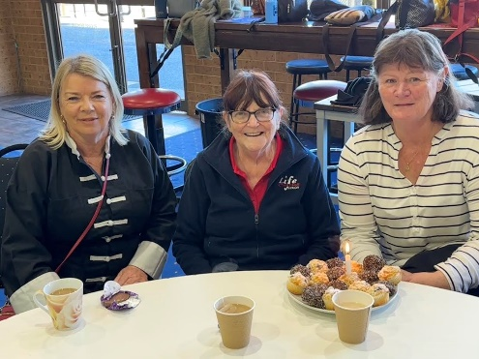T

 Don’t they

The Thursday Tai Chi Group had a lovely 2024.

We continue to learn & at present we are doing our Tai Chi at Arundel Estate.

They have made us very welcome and looking forward to starting back on 13th February 2025 at 1000am.

This will be our 4th year, and we have a lot of fun and go out to plenty of lunches.

If anyone is interested in coming, please pop in and see what it's like and you are welcome to sit and have a cuppa afterwards.

Georgie Hall

0418 124 890

**Christmas Party**

We enjoyed the day at the Taylors Lakes Hotel. Great venue for our needs. I believe the food was way below the standard we have come to expect at the venue. However, the day was very enjoyable due to camaraderie of our club members and their friends.

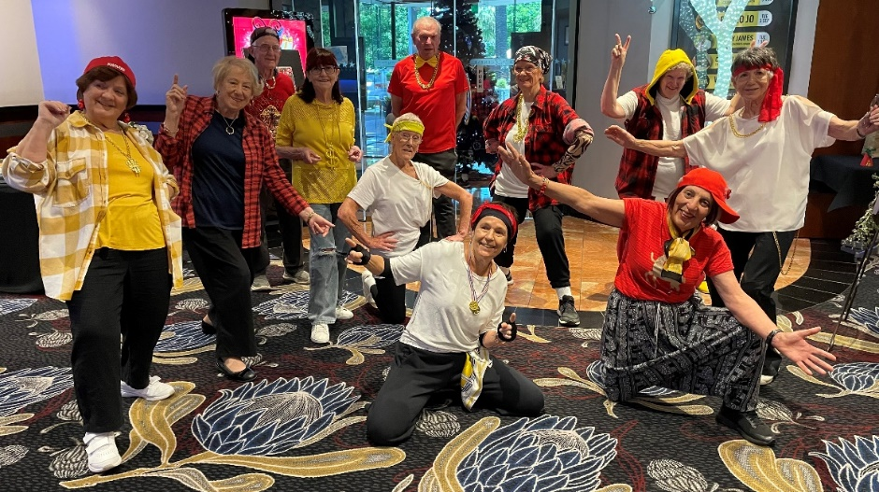

***These members entertained us with HipHop- lead by Jenny Kelly***

***Also entertaining us***

***Chorus Line lead by-***

***Di Lukey***

***These members are just dreamers***

***Bunning’s Sausage Sizzle:***

During the Christmas break our sausage sizzle team have been doing their stuff.

21st December 5th January 25th January.

Our sizzles are a major revenue booster. We have a team who have it down pat and it would be remiss of me not to name them. We do need a backup list, if any member is interested, please let us know… Team members- Georgie, Joanna, Luckey, Margaret, Jenny, Maria, Kerry, Joan and Gavin. “Thank you all” this revenue allows us to keep our activities at a low rate, allowing members to attend more than one event. We gratefully acknowledge Bunnings for their unconditional support.

***Theatre***

All these shows are pensioner/concession rates.

What out for the Theatre Lists available on a Monday.Norma carries out a remarkable job. We could assist by adding to the list early and not loosing tickets.

Sausage sizzlers were not the only members out and about. Norma had the theatre goers out strutting their stuff. I believe (can’t print all details) they had a very happy day. SISTER ACT -Regent Theatre 15/1/25

**Monday 12.30 pm- 3.00pm**

**Activities include coffee/tea/chat**

**Register for outings/activities/special events**

1st Monday of Month Committee Meeting /Chair Aerobics 1.00pm / Bingo 2.00 pm

2nd Monday Month Hip Hop / Members Draw

3rd Monday Month Trading / Books / Raffles /Bingo / Hip Hop

4th Monday Speaker / Hip Hop

|  |
| --- |
| **OUR CONVENERS** |
| **MONDAY** |
| ***Ukulele*** – 10.00-11.00am – Judy Waterhouse 0438 142 700 |
|  |
| **TUESDAY** |
| ***Tai Chi*** – 10-11am Judy Waterhouse 0438 142 700 |
| ***Golf*** – 9.30am for 10.00am start (Keilor Public Golf Course) Convener: TBA |
|  |
| **WEDNESDAY** |
| ***Chorus Line*** – 10.00-11.00am – Vivian Scarr 0417 120 069 |
| ***Walking Football*-** (Keilor Basketball Stadium) 1.00-2.00pm Convener: TBA |
|  |
| **THURSDAY** |
| ***Thursday Tai Chi*** - 9.30-10.30am - Georgina Hall 0418 124 890 |
| ***Bike Riding*** *– 10.00am* - Judy Waterhouse 0438 142 700 |
| ***Walking Basketball –*** (Keilor Basketball Stadium) 11.30 – 12.30 |
| **FRIDAY** |
| ***Nordic Walking/Walking*** (Brimbank Park) 9.30-10.30am Jill Kriechbaum 0431 182 713 |
| ***Social Coffee and Chat*** (Brimbank Park) 10am Fran Robins 9390 4625 (1st Friday of the month) |
|  |
| **SATURDAY** |
| ***Early Bird Breakfast*** (Café Brimbank Park) 9.00am Kerrie Hallows 0415 133 554 (Last |
| Saturday) |

**Chair Aerobics** - 1st Monday of the month 1.00 pm.

**Bingo** – 1st Monday and 3rd Wednesday of the month 2.00pm

**Hip Hop** – Every Monday 12.30 (Except 1st Monday when there is Chair Aerobics)

**Website Master** – Trevor Withers -t.withers47@bigpond.com

**Bus Trips** – Dianne Robinson – 0438 242 512

**Live Theatre** – Norma Cocks – 0407 097 216

**Club Uniforms** –Glenys Adams - 0414 757 632

**Dine-outs** – Maria Rizzas – 0407 865 075

**Trading Table –** Sandra Bennett – 0452 366 380

**Hospitality –** Joanna Sergiou – 0409 182 025

***Debit Details For any Payments:* Cash payments desk in KLAC Club Rooms**

* **Direct Debit: *MUST include description***

**BSB No. 063 591**

**Account No. 10137201**

**Account Name. Keilor Life Activities Club Inc.**