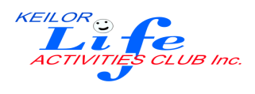

P.O Box 99 Keilor 3036

MEMBERSHIP FORM

**Membership Joining Fee $35 Including Name Badge**

………………………………………………………………… Phone No. ……………………

(Given Name) (Family Name)

Signature

………………………………………………… Phone No. ……………………

(Given Name) (Family Name)

Signature

Address. ……………………………………………………

Postcode………………..

Email: ……………………………………………………….

Emergency Contact Name…………………………………………… Contact No……………….

METHODS FOR PAYMENT OF RENEWAL:

* Post this completed form, with cheque, to;

The Membership Secretary, P.O. Box 99 Keilor, 3036 or

* Hand your $35, cash or cheque payment in a self-addressed envelope marked Membership at the Cash Payments desk in KLAC Club rooms.
* Direct Debit- **BSB No. 063 591 *MUST include description***

**Account No. 10137201**

**Account Name Keilor Life Activities club Inc.**

KLAC Rules available on request or visit website www.keilorlife.com

Participation in the KLAC Activities is at your own risk.

Photographs may be taken during activities or in the club rooms, if you do not wish these photos to be used in any KLAC publications please notify the Secretary.

Committee Approval -

**Office Use**:

Received Cheque //Cash, Direct Debit $...........

Receipt No……………………… Signature