 NEWSLETTER

# **OCTOBER-NOVEMBER 2023**

Meet: Mondays @ 10am Keilor Sports Club.

Old Calder Highway, Keilor

Club Patrons: Dr Les Norton, Ray Dodd, Tony Borello, Craig Teal

**33**

PO Box 99, Keilor

www.keilorlife.com

|  |  |  |
| --- | --- | --- |
| *President:* *Joan Ellis 9336 2374*  *Mob: 0408 362 697*  *Email: Jel48981@bigpond.net.au* | *Secretary:* *Nancy Pipe – 9417 4228*  *Mob: 0430 350 371*  *Email: allan.pipe@bigpond.com* | ***Membership******Secretary;*** *Glenys Adams - 9077 0713* Mob: : 0414 757 632  **Club Patrons**  We gratefully acknowledge the support of our patrons.  Dr. Les Norton Ray Dodd  **Club Supporters**  Tony Borello Brad Teal  Accountant Newsletter [printing]  Email: glenysa@optusnet.com.au |
| *Vice-President:**Judith Cave 9336 1133* *Mob:0408 301 057*  [*rexjude@hotmail.com*](mailto:rexjude@hotmail.com) | *Newsletter Editor:* *Nancy Pipe – 0430 350 371*  *allan.pipe@bigpond.com*  ***Ass. Newsletter Editor*** *Judy Waterhouse*  judywaterhouse@optusnet.com.au | *Treasurer:* *Sue Lovell – 0402 056 070*  *lovellsue@hotmail.com*  ***Ass. Treasure****r Neil Webster*  *Neil13web@aol.com* |
| **Carer**: Judith Cave 0408 301 057 | **Web *Master***: [t.withers47@bigpond.com](mailto:t.withers47@bigpond.com) | *Photographer*: Dianne Robinson 0438 242 512 |

***PRESIDENT’S MESSAGE OCTOBER 2023:***

*Here we go, the run down to Christmas 2023. Christmas makes me reflect on my parents and life as we grew up. It also makes me more aware of the people around me. Senior citizens have had more time than most to share their love with others. When you think of the seniors in your life you know that they have made the most of that time. This is because most seniors have learned the value of time. They know the value of loving and encouraging words. Most importantly, they share those words freely. Keep this in mind as we enter what we call the “Crazy Season”*

*We all look forward to the Christmas concert each year, many are practising items. If there is a member who has an item that we can all enjoy, please let me know and we can add you on the program. If you have photos of events/activities, please forward them to Nancy. There will be a special edition of the newsletter in December.*

*Keep Well*

*Joan*

*“****You Are Never Too Old to Set Another Goal or To Dream a New Dream”***

and very much appreciated by our members.

**Club Supporters**

We gratefully acknowledge the ongoing support of:-

Warwick Borello Accountant

Woodards WNewsletter printing

There is

new logo



 There were several members that were sent "Thinking of You" cards and for folk who have been in hospital “Get Well” cards have also been sent, and We wish all a speedy recovery.

For members who are “Just Not Quite Right” we can only hope this bit of sunshine can only make them feel wonderful and feeling much better.



The committee and members would like to take this opportunity to extend a warm welcome to Joyce Tabone and Christine Phillips and hope that they will join us in many of the activities our Club has to offer.

***Theatre Enthusiasts:***



* ***Grease***
* ***Chicago***
* ***And hopefully Beauty and the Beast***

**Watch this space more information in next month's Newslette***r*

***Dine Out – Friday 20th October – 12.00:***



***Jasmine House***

395 Keilor Road, Niddrie

Please remember to put your name on the list at the activity table.

**\**

**Breakfast Is Served:**

Taylors Lakes Motel Café:

9.00am Last Saturday of the month:

If  you haven’t joined us before, come and give it a try!  They have a mouth-watering selection of goodies, and you can go back for seconds or even thirds!   Great value for money, everything from cereals, bacon and eggs sausages mushrooms (safe ones) to fruit and pastries, all for $25!  Good company and good food…. You can’t go wrong.  Come and give it a try!

***Bus Trip – Friday 24th November:***



Destination: Great Ocean Road

Depart Club Rooms: 8.30am sharp

Arrive back: Approx. 5.00 - 5.30 pm

**Cost: $60**

***Morning Tea***: Great Ocean Road Chocolaterie and Ice Creamery

Bellbrae (**At own expense**)

***Lunch***: Barwon Heads Hotel **(included**)

.After lunch we will head for the Fort at Queenscliff for a very interesting tour.

{This was constructed on Shortlands Bluff to defend the entrance to Port Phillip Bay. It was manned from 1883 to 1944. You can look up the history so come on the Bus trip to see it.

***Christmas Party - Monday 27th November - 7-11pm:***

**What! Already!   Can’t be …but it is**!



Change of venue this year … looking for a new vibe to get the party started!    Taylors Lakes Hotel, Starlight room has been chosen to kick off the festive season and introduce our newer members to as much fun and frivolity as their bodies can cope with.  Maybe an afternoon nap might be required, so you can last till 11pm without yawning! Kick off time is 7pm for dinner and dancing  so put the date in your calendar.   List is out at the payment table

**Venue: Taylor’s Lakes Hotel**

**“Starlight Room”**

**COST: $50**

**Things We can learn from a dog.**

* Never pass up the opportunity to go for a joyride.
* Allow the experience of fresh air land wind in your face to be pure ecstasy.
* When loved ones come home, always run to greet them
* Let others know when they’ve invaded your territory.
* Take naps and stretch before rising.
* Run, romp, and play daily … Eat with gusto and enthusiasm.
* Be loyal .. Never pretend to be something you’not.
* If you want what lies buried, dig until you find it.
* When someone is having a bad day, be silent, sit close by and nuzzle them gently
* Thrive on attention and let people touch you.
* Avoid biting when simply when a growl will do
* On hot days, drink lots of water and rest under a shady tree.
* When you’re happy, dance around and wag your entire body]
* No matter how often your scolded don’t buy into the “guilt thing” run right back and make friends.
* Bond with your pack.
* Delight the simple joy of a long walk.

***Northwest Walking Football Games.***

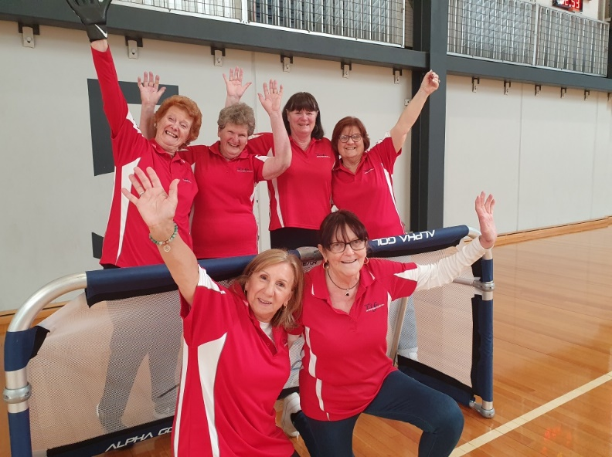 On 28th September 2023, teams from the Northwest gathered to play walking soccer at Keilor Basketball Stadium.

Teams arrived from Whittlesea, Sunbury, Kyneton, Bendigo, Ballarat and Featherbrook. Some hubs brought ladies, men’s, and mixed sides; most teams managed to get in three games each.

This proved to be a very enjoyable day for all topped off with pizza for lunch, with plenty of stiff bodies but no serious injuries, which is what we all want to see.

For the first time ever our Keilor men’s side had the luxury of a sub. Two players from the new West Sunshine hub came to help us out and both played with aplomb as guest players for us. Keilor men managed a draw and a couple of losses but had lots of fun with Lucky stunning at saves in goal.

Our lady’s side, even with thinned ranks on the day for various reasons, fared much better than the men with a couple of draws and a win, so remain unbeaten.

Keilor intend to offer support to the new hub in West Sunshine by turning out on the first Friday of the month from 1/2pm, and if our members wish to go more often, they can do so.

**Kelvin Bennett**



* **16TH OCTOBER – NEXT TRADING TABLE**
* **NO CLUB MONDAY 6th NOVEMBER**
* **24TH NOVEMBER – BUS TRIP**
* **27TH NOVEMBER – CHRISTMAS PARTY**
* **11TH DECEMBER – CHRISTMAS CONCERT**
* **X**

***Debit Details For any Payments:***

* **Cash payments desk in KLAC Club Rooms**
* **Direct Debit: *MUST include description***

**BSB No. 063 591**

**Account No. 10137201**

**Account Name. Keilor Life Activities Club Inc.**

|  |  |  |  |  |  |
| --- | --- | --- | --- | --- | --- |
| **OCTOBER 2023** | | | **NOVEMBER 2023** | | |
| Mon | 9 | Ukulele | Mon | 6 | **NO CLUB** |
| Tue | 10 | Tai Chi/Golf | Tue | 7 | **CUP DAY** |
| Wed | 11 | Chorus Line/Walking Football | Wed | 8 | Chorus Line/Walking Football |
| Thur | 12 | Beginners Tai Chi/Bike Riding | Thur | 9 | Beginners Tai Chi/Bike Riding |
| Fri | 13 | Nordic Walking | Fri | 10 | Nordic Walking/Coffee Club |
| Sat | 14 |  | Sat | 11 |  |
| Sun | 15 |  | Sun | 12 |  |
| Mon | 16 | **Club Day/Trading Table/Raffle/Books**/Ukulele | Mon | 13 | Committee Meeting /Ukulele |
| Tue | 17 | Tai Chi/Golf | Tue | 14 | Tai Chi/Golf |
| Wed | 18 | Chorus Line/Walking Football | Wed | 15 | Chorus Line/Walking Football |
| Thur | 19 | Beginners Tai Chi/Bike Riding | Thur | 16 | Beginners Tai Chi/Bike Riding |
| Fri | 20 | Nordic Walking/Dine Out **Dine Out Jasmine House Niddrie** | Fri | 17 | Nordic Walking/ |
| Sat | 21 |  | Sat | 18 |  |
| Sun | 22 |  | Sun | 19 |  |
| Mon | 23 | Ukulele | Mon | 20 | **Club Day/Trading Table/Books/Raffle** /Ukulele |
| Tue | 24 | Tai Chi/Golf | Tue | 21 | Tai Chi/Golf |
| Wed | 25 | Chorus Line/Walking Football | Wed | 22 | Chorus Line/Walking Football |
| Thur | 26 | Beginners Tai Chi/Bike Riding | Thur | 23 | Beginners Tai Chi/Bike Riding |
| Fri | 27 | Nordic Walking | Fri | 24 | **BUS TRIP** |
| Sat | 28 | **BREAKFAST** | Sat | 25 | **BREAKFAST** |
| Sun | 29 |  | Sun | 26 |  |
| Mon | 30 | Ukulele | Mon | 27 | Ukulele **XMAS PARTY** |
| Tue | 31 | Tai Chi/Golf | Tue | 28 | Tai Chi/Golf |
|  |  | **NOVEMBER 2023** | Wed | 29 | Chorus Line/Walking Football |
| Wed | 1 | Chorus Line/Walking Football | Thur | 30 | Beginners Tai Chi/Bike Riding |
| Thur | 2 | Beginners Tai Chi/Bike Riding |  |  |  |
| Fri | 3 | Nordic Walking |  |  |  |
| Sat | 4 |  |  |  |  |
| Sun | 5 |  |  |  |  |
|  |  |  |  |  |  |
|  |  |  |  |  |  |

**Drop-in Day Clubrooms**

**Monday 10.00am- 2.00pm**

**Activities include coffee/tea/chat**

**Register for outings/activities/special events**

1st Monday of Month – Committee Meeting /Chair Aerobics 12.00

2nd Monday Month –

3rd Monday Month – includes Theme Day / Books / Raffles

4th Monday –

|  |
| --- |
| **OUR CONVENERS** |
| **MONDAY** |
| *UKULELE* – 10-11.00am – Judy Waterhouse 0438 142 700 |
|  |
| **TUESDAY** |
| *TAI CHI* – 10-11am Judy Waterhouse 0438 142 700 |
| *MORN. MELODIES* (Taylors Lakes Hotel 1st Tues Month) Brian Cameron 8361 5846 |
| *GOLF* – 9.30am for 10.00am start (Keilor Public Golf Course) Maddie Viering 0435 945 554 |
|  |
| **WEDNESDAY** |
| *CHORUS LINE* – 10-11am – Vivian Scarr 0417 120 069 |
| *MORN.MELODIES* (Skyways Airport West Last Wed Month) Margaret Cameron 8361 5846 |
| *WALKING FOOTBALL*- (Keilor Basketball Stadium) 1.00pm Kelvin Bennett 0415 652 995 |
|  |
| **THURSDAY** |
| *BEGINNERS TAI CHI* - 9.30am - Georgina Hall 0418 124 890 |
| BIKE RIDING – 10.00am - Judy Waterhouse 0438 142 700 |
|  |
| **FRIDAY** |
| *NORDIC WALKING* (Brimbank Park) 9.30am Jill Kriechbaum 0431 182 713 |
| *SOCIAL COFFEE AND CHAT* (Brimbank Park) 10am Fran Robins 9390 4625 (1st Friday) |
|  |
| **SATURDAY** |
| *EARLY BIRD BREAKFAST* (Taylors Lakes Motel) 9.00am Kerrie Hallows 0415 133 554 (Last |
| Saturday) |
|  |

**Website Master** – Trevor Withers -t.withers47@bigpond.com

**Bus Trips** – Dianne Robinson – 0438 242 512

**Live Theatre** – Norma Cocks – 0407 097 216

**Club Uniforms** –Glenys Adams - 0414 757 632

**Dine-outs** – Maria Rizzas – 0407 865 075

**Trading Table –** Sandra Bennett – 045 236 6380

**Hospitality –** Joanna Sergiou – 0409 182 025

***Sports Club Contacts:***

**Kitchen, Bar, Furniture, Room layout Issues** – Dick Joyner – 0415 956 979

**Technical Issues – Computers, TV’s, Microphones, Scoreboard** – Lee Falcke – 0438 907 772

**General Club Issues & Maintenance** – Russell Pollock – 0417 055 529

**Bar Stocking/Ordering** – Lee Falcke – 0438 907 772

**Changerooms and Groun**d – Applicable Club & Russell Pollock 0417 055 529

**Function Bookings** – Dick Joyner – 0415 956 979