 NEWSLETTER

# **SEPTEMBER-OCTOBER 2023**

Meet: Mondays @ 10am Keilor Sports Club.

Old Calder Highway, Keilor

Club Patrons: Dr Les Norton, Ray Dodd, Tony Borello, Craig Teal

**33**

PO Box 99, Keilor

www.keilorlife.com

|  |  |  |
| --- | --- | --- |
| *President:* *Joan Ellis 9336 2374*  *Mob: 0408 362 697*  *Email: Jel48981@bigpond.net.au* | *Secretary:* *Nancy Pipe – 9417 4228*  *Mob: 0430 350 371*  *Email: allan.pipe@bigpond.com* | ***Membership******Secretary;*** *Glenys Adams - 9077 0713* Mob: : 0414 757 632  **Club Patrons**  We gratefully acknowledge the support of our patrons.  Dr. Les Norton Ray Dodd  **Club Supporters**  Tony Borello Brad Teal  Accountant Newsletter [printing]  Email: glenysa@optusnet.com.au |
| *Vice-President:**Judith Cave 9336 1133* *Mob:0408 301 057*  [*rexjude@hotmail.com*](mailto:rexjude@hotmail.com) | *Newsletter Editor:* *Nancy Pipe – 0430 350 371*  *allan.pipe@bigpond.com*  ***Ass. Newsletter Editor*** *Judy Waterhouse*  judywaterhouse@optusnet.com.au | *Treasurer:* *Sue Lovell – 0402 056 070*  *lovellsue@hotmail.com*  ***Ass. Treasure****r Neil Webster*  *Neil13web@aol.com* |
| **Carer**: Judith Cave 0408 301 057 | **Web *Master***: [t.withers47@bigpond.com](mailto:t.withers47@bigpond.com) | *Photographer*: Dianne Robinson 0438 242 512 |

***PRESIDENT’S MESSAGE SEPTEMBER 2023:***

Thank you to all our committee members who at the KLAC, AGM, 2023, agreed to support our members, for the next twelve months. Giving, support, care and time to our club and our senior community in general. You! are all beautiful people.

We all know that at this very precious time of our lives, there may be obstacles we have to bear, however, we, are the most resilient bodies you will ever know and will make it work and keep on smiling.

Our committee has recognised that we need to meet and greet the many members who enjoy an activity within our club. Many of whom the committee has never met, and you have never seen us. We also acknowledge that you might think that is how it is and that your activity is the be all and end all (probably is) This is not how it is, and we need all members to know, there are many activities to be enjoyed by you, your partners, and your friends in our club. You will meet us, the committee, at your activity of choice during October. We want to meet you, and for you to learn of our other activities that are both physical and passive. You don’t need to be jumping out of your skin, you can be attending a lunch or a theatre presentation with mates.

October, senior’s month, many activities / events, happen through Victoria for a cheaper fee and many at no charge. Please take advantage of what is on offer, remembering that transport is free. Get some mates and go to Bendigo or Geelong for lunch. Enjoy! Tuesday and Thursday, the first week in October, we are show casing activities at the Keilor golf course. We would enjoy meeting you and your friends to try a new activity that will enhance your life and that you can enjoy each week as a KLAC activity.

Enjoy Spring, and what it has to offer.

Keep well,

*Joan*

**“Just one small positive thought in the morning can change your whole day.”**

and very much appreciated by our members.

**Club Supporters**

We gratefully acknowledge the ongoing support of:-

Warwick Borello Accountant

Brad TealNewsletter printing

Office of Natalie Hutchens MP

There is

***Vale Sylvia De Campo:***

Our darling Sylvia passed away recently and left a big hole in the lives of all her knew and loved her. Syvia joined our Tai chi group in June 2010, so we have had the pleasure of her company all this time. She would have been 101 in two months’ time and has spent the last year in a nursing home where she was also greatly loved.

Our Sylvia had a remarkable life and was a woman ahead of her time in many ways and drove an FJ Holden when many women never even got a drivers license. There was no stopping this dynamo, and when it was time to hand in the car keys, she was a well-known sight in her bright red mobility scooter, which took her out every day and enabled her to live an independent life and do her shopping in the local village shops. These shop keepers looked out for her, even visiting her in the nursing home, were there for her 100th birthday and at the Celebration of her Life in our Club rooms.

Sylvia rarely missed our Tai Chi class, and we figured if she could be there for 10am start, none of us had any excuse. To say she was an inspiration is only a small part of the influence she had on all of us and everyone she encountered. We looked up to her with a reverence rarely given to many people and will be sorely missed by her family, friends and neighbors, and all those lucky enough to be in her company.

It is with a heavy heart we say farewell to this much adored lady. May she rest in peace knowing she touched so many lives and remained an avid “Bulldogs” supporter to the end.

***Carer’s Report:***



Cards were sent out to all sickies and anyone in need of a thinking of you card.

Sympathy card sent to Ruth Branford

Please let us know if you know of anyone who needs cheering up.

***Dine Out – Friday 15th September – 12.00:***



**Taylors Lakes Hotel**

Melton Highway, Taylor’s Lakes

***Dine Out – Friday 20th October – 12.00:***



***Jasmin House***

395 Keilor Road, Niddrie

***Books***



Each month we seem to average $50 to $60, which is amazing.

Thank you to the members who buy the books as well as the ones who donate.

Also, to the members who put in their donation of silver coins, gold coins and notes. All of this goes to the Royal Childrens Hospital.

Just a reminder when the books have circulated a few times I then take them to Helping Hands, Aged Care Facilities, and the Men’s Shed Library at Westfield Airport West.

Best Wishes

Georgie

***Chair Aerobics:***

Lucy has been our leader for a long time, and on the first Monday at 12.00, she comes looking gorgeous, bursting with energy and full of enthusiasm, ready to get us going. Mainly it has been a cast of regulars, putting bums on seats, but we want to encourage our new members to come and join us and get those still old joints moving and arms and legs marching. It’s a lot of fun and it is exercise well within most capabilities and you will be able to put on music at home and continue with the good work. You don’t need fancy Lycra, whatever you are wearing on the day is fine, so put the date and time in your diary and join us.

The club feel this activity serves us well and is free to all who want to take part, so come and give it a go.

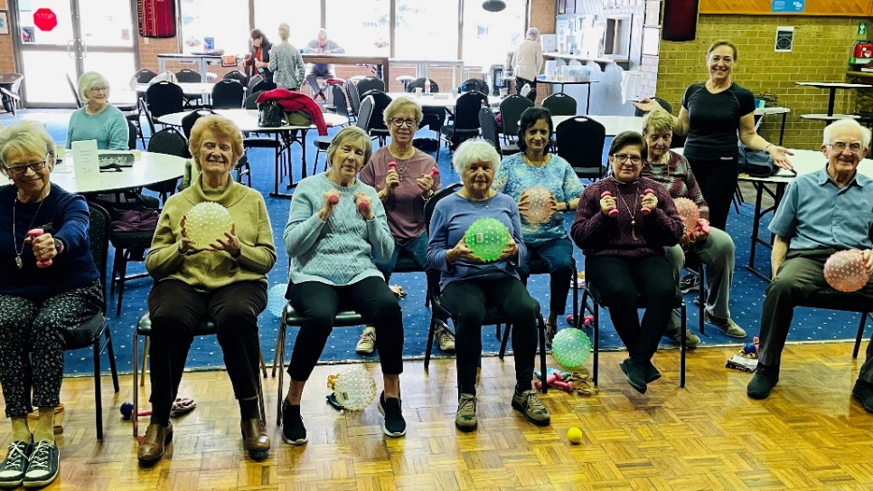

***JUST FOR LAUGHS***: - My Travel Plans –

I have been in many places, but I've never been in Kahoots. Apparently, you can't go alone. You have to be in Kahoots with someone.

I've also never been in Cognito. I hear no one recognizes you there.

I have, however, been in Sane. They don't have an airport; you have to be driven there. I have made several trips there, thanks to my children, friends, family and work.

I would like to go to Conclusions, but you have to jump, and I'm not too much on physical activity anymore.

I have also been in Doubt. That is a sad place to go, and I try not to visit there too often.

I've been in Flexible, but only when it was very important to stand firm.

Sometimes I'm in Capable, and I go there more often as I'm getting older.

One of my favourite places to be is in Suspense! It really gets the adrenaline flowing and pumps up the old heart! At my age I need all the stimuli I can get!

I  have been in Continent, but I don't remember what country I was in. It's an age thing. They tell me it is very wet and damp there.

***Theatre Enthusiasts:***



**MAMA MIA – THE MUSICAL – PRINCESS THEATRE**

**Wednesday 25th October – 1.00pm**

**Concession Group Price - $85.50**

***Please confirm and pay by Monday 28th August***



* ***Grease***
* ***Chicago***
* ***And hopefully Beauty and the Beast***

**Watch this space more information in next month's Newslette***r*

***MOULIN ROUGE***

Part of a large group at Moulin Rouge the Musical a spectacular show.

Thank you to all the Theatre Enthusiasts for their support.

**Norma**

***Bus Trip – Friday 24th November:***



Destination: Great Ocean Road

Depart Club Rooms: 8.30am sharp

Arrive back: Approx. 5.00 - 5.30 pm

**Cost: $60**

***Morning Tea***: Great Ocean Road Chocolaterie and Ice Creamery

Bellbrae (**At own expense**)

***Lunch***: Barwon Heads Hotel **(included**)

.After lunch we will head for the Fort at Queenscliff for a very interesting tour.

{This was constructed on Shortlands Bluff to defend the entrance to Port Phillip Bay. It was manned from 1883 to 1944. You can look up the history so come on the Bus trip to see it.

**Daylight Saving Begins:**

**Sunday 1 October 2023**

Move your clock forward one hour at 2am

***Committee Corner***:

* Congratulations to the Committee for 2023-2024, Some members probably don’t know the Committee by sight, we have put in this photo so you can recognise them. The only person missing from the photo is our Assistant Treasurer.

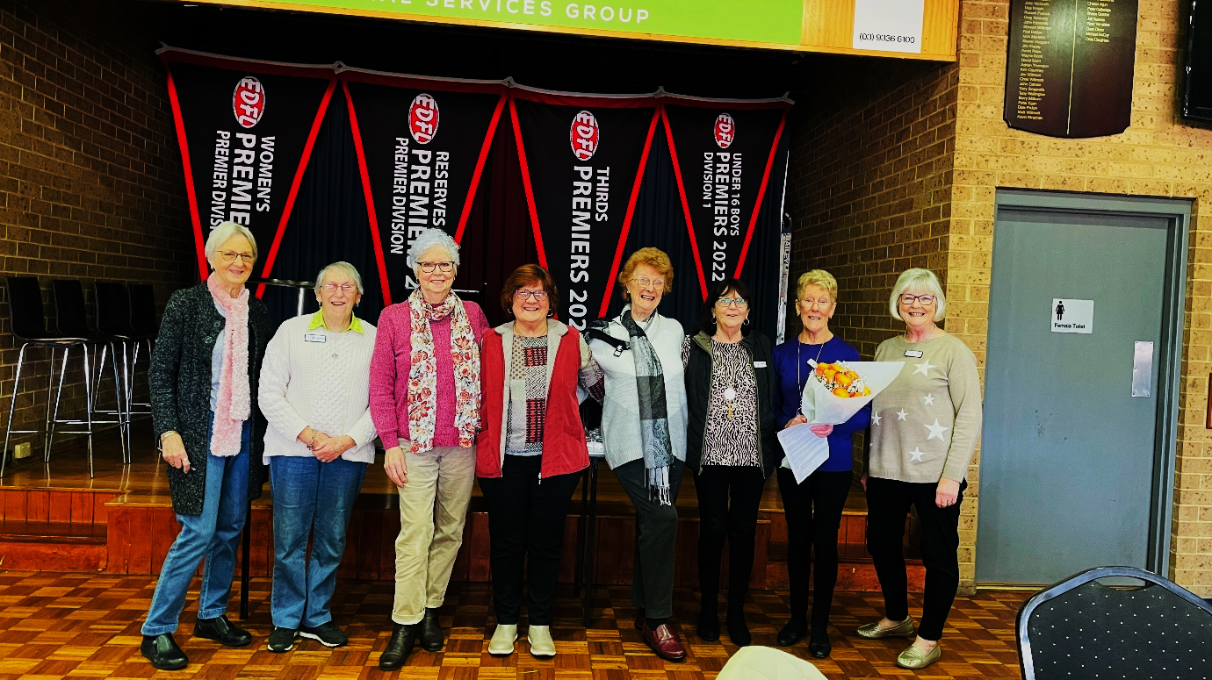

President; Joan Ellis

Vice President: Judith Cave

Secretary; Nancy Pipe

Treasurer; Sue Lovell

Ass. Treasurer; Neil Webster

Membership Secretary; Glenys Adams

**Committee Members**.

Norma Cocks

Dianne Robinson

Jenny Craig



Most of you by now have completed your Membership Renewal for 2023/24. We thank you for your prompt response and for those who haven’t, this is a gentle reminder.

***Direct Debit Details For Payments:***

* **Cash payments desk in KLAC Club Rooms**
* **Direct Debit: *MUST include description***

**BSB No. 063 591**

**Account No. 10137201**

**Account Name. Keilor Life Activities Club Inc.**

|  |  |  |  |  |  |
| --- | --- | --- | --- | --- | --- |
| **SEPTEMBER** | | | **OCTOBER 2023** | | |
| Mon | 11 | Ukulele | Mon | 9 | Ukulele |
| Tue | 12 | Tai Chi/Golf | Tue | 10 | Tai Chi/Golf |
| Wed | 13 | Chorus Line/Walking Football | Wed | 11 | Chorus Line/Walking Football |
| Thur | 14 | Beginners Tai Chi/Bike Riding | Thur | 12 | Beginners Tai Chi/Bike Riding |
| Fri | 15 | Nordic Walking/**Dine Out Taylors Lakes Hotel** | Fri | 13 | Nordic Walking |
| Sat | 16 |  | Sat | 14 |  |
| Sun | 17 |  | Sun | 15 |  |
| Mon | 18 | Club Day/Raffle/Books/Ukulele | Mon | 16 | Club Day/Trading Table/Books/Raffle /Ukulele |
| Tue | 19 | Tai Chi/Golf | Tue | 17 | Tai Chi/Golf |
| Wed | 20 | Chorus Line/Walking Football | Wed | 18 | Chorus Line/Walking Football |
| Thur | 21 | Beginners Tai Chi/Bike Riding | Thur | 19 | Beginners Tai Chi/Bike Riding |
| Fri | 22 | Nordic Walking | Fri | 20 | Nordic Walking/**Dine Out Jasmin House Niddrie** |
| Sat | 23 |  | Sat | 21 |  |
| Sun | 24 |  | Sun | 22 |  |
| Mon | 25 | Ukulele | Mon | 23 | Ukulele |
| Tue | 26 | Tai Chi/Golf | Tue | 24 | Tai Chi/Golf |
| Wed | 27 | Chorus Line/Walking Football | Wed | 25 | Chorus Line/Walking Football |
| Thur | 28 | Beginners Tai Chi/Bike Riding | Thur | 26 | Beginners Tai Chi/Bike Riding |
| Fri | 29 | Nordic Walking | Fri | 27 | Nordic Walking |
| Sat | 30 | **BREAKFAST** | Sat | 28 | **BREAKFAST** |
|  |  | **OCTOBER** | Sun | 29 |  |
| Sun | 1 |  | Mon | 30 | Ukulele |
| Mon | 2 | Committee Meeting/Ukulele/Chair Aerobics | Tue | 31 | Tai Chi/Golf |
| Tue | 3 | Tai Chi/Golf |  |  |  |
| Wed | 4 | Chorus Line/Walking Football |  |  |  |
| Thur | 5 | Beginners Tai Chi/Bike Riding |  |  |  |
| Fri | 6 | Nordic Walking/**Coffee Club** |  |  |  |
| Sat | 7 |  |  |  |  |
| Sun | 8 |  |  |  |  |
|  |  |  |  |  |  |

**Drop-in Day Clubrooms**

**Monday 10.00am- 2.00pm**

**Activities include coffee/tea/chat**

**Register for outings/activities/special events**

1st Monday of Month – Committee Meeting /Chair Aerobics 12.00

2nd Monday Month –

3rd Monday Month – includes Theme Day / Books / Raffles

4th Monday –

|  |
| --- |
| **OUR CONVENERS** |
| **MONDAY** |
| *UKULELE* – 10-11.00am – Judy Waterhouse 0438 142 700 |
|  |
| **TUESDAY** |
| *TAI CHI* – 10-11am Judy Waterhouse 0438 142 700 |
| *MORN. MELODIES* (Taylors Lakes Hotel 1st Tues Month) Brian Cameron 8361 5846 |
| *GOLF* – 9.30am for 10.00am start (Keilor Public Golf Course) Maddie Viering 0435 945 554 |
|  |
| **WEDNESDAY** |
| *CHORUS LINE* – 10-11am – Vivian Scarr 0417 120 069 |
| *MORN.MELODIES* (Skyways Airport West Last Wed Month) Margaret Cameron 8361 5846 |
| *WALKING FOOTBALL*- (Keilor Basketball Stadium) 1.00pm Georgina Hall 0418 124 890 |
|  |
| **THURSDAY** |
| *BEGINNERS TAI CHI* - 9.30am - Georgina Hall 0418 124 890 |
| BIKE RIDING – 10.00am - Judy Waterhouse 0438 142 700 |
|  |
| **FRIDAY** |
| *NORDIC WALKING* (Brimbank Park) 9.30am Jill Kriechbaum 0431 182 713 |
| *SOCIAL COFFEE AND CHAT* (Brimbank Park) 10am Fran Robins 9390 4625 (1st Friday) |
|  |
| **SATURDAY** |
| *EARLY BIRD BREAKFAST* (Taylors Lakes Motel) 9.00am Kerrie Hallows 0415 133 554 (Last |
| Saturday) |
|  |

**Website Master** – Trevor Withers -t.withers47@bigpond.com

**Bus Trips** – Dianne Robinson – 0438 242 512

**Live Theatre** – Norma Cocks – 0407 097 216

**Club Uniforms** –Glenys Adams - 0414 757 632

**Dine-outs** – Maria Rizzas – 0407 865 075

**Trading Table –** Sandra Bennett – 045 236 6380

**Hospitality –** Joanna Sergiou – 0409 182 025

***Sports Club Contacts:***

**Kitchen, Bar, Furniture, Room layout Issues** – Dick Joyner – 0415 956 979

**Technical Issues – Computers, TV’s, Microphones, Scoreboard** – Lee Falcke – 0438 907 772

**General Club Issues & Maintenance** – Russell Pollock – 0417 055 529

**Bar Stocking/Ordering** – Lee Falcke – 0438 907 772

**Changerooms and Groun**d – Applicable Club & Russell Pollock 0417 055 529

**Function Bookings** – Dick Joyner – 0415 956 979